
at

INSTITUTE OF TECHNOLOGY OF CAMBODIA

FACULTY OF GEO-RESOURCES AND GEOTECHNICAL ENGINEERING

INTERNSHIP REPORT

TOPIC: Depositional Environment and Petrified wood Identification at Lom Phat district, Ratanakiri, Cambodia.

LECTURER: HENG MUOY YI
PREPARED BY: DY RATTHA

Academic Year: 2023-2024

ACKNOWLEDGEMENT
I owe a great deal of gratitude to all the persons who contributed in different ways to the completion of this report. First of all, I would want to thank my family, especially my mother, for their support, encouragement, and care while I was attending university and for their efforts to provide me with all the wonderful opportunities in life.
Secondly, I want to sincerely thank H.E. Prof. PO Kimtho for his excellent administration and leadership at the Institute of Technology of Cambodia. I want to express sincere thanks to Assist. Prof. ENG Chandoeun, Dean of the Faculty of Geo-Resources and Geotechnical Engineering (GGE), for his leadership, coordination, and support of our division.
I would like to acknowledge Ms. HENG MOUY YI who is project leader in particular for her support, motivation, advice, teaching and sharing, constructive criticism, and correction for my work in this Fourth-year report.
Furthermore, I would like to thank Mr. LIM Vanchan for guidance, explanation and problem-solving skill during my 4th year internship. In addition, I extend my sincere gratitude to Department Heritage Park, General Department of Local Community Ministry of Environment, Cambodia for giving me access to my field area and for providing support during my fieldwork in Ratanakiri province.
Last but not least, I am glad to thank Mr. SENG Mengly, Mr.HENG Ratha, Mr SAY Sokvireak and my seniors Ms. HENG Jolsa, Ms. Diep Sodika, Ms. Chhun They, Mr. Sun Chhunly, Mr. Chhun Chhaya and my friends who always stood by me, encouraged me, provided many ideas, and helped me to achieve this report.

ABSTRACT
The term “petrified wood” is preferred by paleobotanists over “permineralized wood” as it describes better the fossil wood where cellular tissues are replaced with minerals. Petrified woods typically form in two geological environments, trees transported by streams and rivers become buried in the fluvial sediments. The research was conducted in Lom Phat, a district located in Ratanakiri province of northeastern Cambodia that lies approximately 588 kilometers from Phnom Penh. This research aimed to characterize petrified wood including depositional and paleoenvironmental contexts. Laboratory methods employed hand specimen descriptions and petrographic analysis using thin section microscopy. By physical properties investigation samples consisted of brownish, grayish and reddish color which was deposited fluvial (non-marine and deltaic environment) and high terrace sand. Through petrographic analysis, it was found out that the wood mainly consists of crystalline quartz linings which were precipitated at a later stage when silica content is low hence allowing development of well-ordered lattices. Quartz crystals also occasionally replaced cells in the wood. It can form layers within the cells, eventually filling their internal spaces. Initially, the silica that adheres to the wood is in an amorphous state, but it gradually becomes more stable by crystallizing into more stable forms. This change involves ongoing polymerization and dehydration. The formation of higher-ordered opal through this process eventually results in the more thermodynamically stable mineral quartz. Distinct growth rings were observed, early wood had more than 60 cells with large cells having thin walls while late wood had three to eight rows of tangentially flattened, thick-walled cells, confiner it as Araucariaceae family, Agathis genera, formed in late Mesozoic period, Upper Jurassic to lower Cretaceous.

ABBREVIATION AND SYMBOLS
Mq Microcrystalline quartz
Opq Opaque mineral
Pl Plagioclase feldspar
PPL Plane-polarized light
Mv Muscovite
Lim Limonite
XPL Cross-polarized light
PPL Plane Polarize light
XRF X-ray fluorescence analysis

TABLE OF CONTENTS
ACKNOWLEDGEMENT i
ABSTRACT ii
ABBREVIATION AND SYMBOLS iii
TABLE OF CONTENTS iv
TABLE OF FIGURES vi
1. INTRODUCTION 1
1.1. Background study 1
1.2. Location of Study area 2
1.3. Problem Statement 2
1.4. Objectives 3
1.5. Scope and Limitation 3
2. LITERATURE REVIEW 4
2.1. Sedimentary rock 4
2.2. Classification of Sandstone 5
2.3. Depositional Environment 9
2.3.1. Transitional environment 10
2.3.2. Marine environments 11
2.3.3. Continental environment 13
2.4. Fossil 14
2.4.1. Petrified Wood 15
2.5. Silicification Wood 17
2.5.1. Model of Silicification 18
2.6. Modes of Preservation 19
2.6.1. Cellular Permineralization 19
2.6.2. Coalified Compressions 19
2.6.3. Authigenic Preservation 20
2.6.4. Duripartic Preservation 20
2.7. Araucariaceae 21
2.8. Gymnosperms conifer 23
2.9. Taxonomy of vascular plants 24
3. METHODOLOGY 26
3.1. Research Framework 26
3.2. Fieldwork 26
3.3. Site excavation 28
3.4. Laboratory Work 29
3.4.1. Hand Specimen Analysis 29
3.4.2. Petrography Analysis 30
3.4.3. Point counting method 33
3.4.4. X-ray fluorescence (XRF) Analysis 33
4. RESULTS AND DISCUSSION 37
4.1. Results 37
4.1.1. Hand specimen 37
4.1.2. Thin section analysis 39
4.1.3. X-ray fluorescence (XRF) 44
4.2. Discussion 48
4.2.1. Petrified wood 48
4.2.2. Depositional Environment 48
5. CONCLUSIONS 50
REFERENCES 51
APPENDIX 53

TABLE OF FIGURES
Figure 1.1. Geological map of study area. The green stars are showing at Lom phat area. 2
Figure 2.1. Sedimentary rock grain size, grain sorting, rounding. 5
Figure 2.2. Classification of sandstone by Pettijohn, 1973 8
Figure 2.3. Classification of Sandstone by Folk, R.L, 1974. 9
Figure 2.4. The Depositional Environment of sediment. 10
Figure 2.5. Summarize depositional environment (Harris and Tefend, 2019) 13
Figure 2.6. Petrified wood. (UCMP fossil types) 18
Figure 2.7. Types of cells present in hardwoods and softwoods. 25
Figure 3.1. Research Flow Chart 27
Figure 3.2. Fieldwork Equipment 29
Figure 3.3. Petrified wood excavation site at Lom Phat area (Department Heritage Park, General Department of Local Community Ministry of Environment, Cambodia, 2020) 30
Figure 3.4. Hand specimen equipment 31
Figure 3.5. Thin Section procedure. 32
Figure 3.6. The equipment is used in thin-section preparation. (A). Large scale rock cutting machine, (B). Small scale rock cutting machine, (C). Grinder, (D). Ultrasonic cleaner machine, (E). Polishing glass plate, (F). Petropoxy resin 154 and Curing agent, (G). 33
Figure 3.7. Fiji program for point counting 34
Figure 3.8. X-Ray Fluorescence Machine (XRF) 35
Figure 3.9. X-ray fluorescence procedure 36
Figure 3.10. A. Binder, B. Compressor, C.LOI Machine, D. Vibrating sample mill, E. Weight scaler, F. Drying oven, G. Quartz Sand, H. Miller sample container, I. Compression holder and Aluminum ring, J. Agat Mortar, K. Cylinder type dices and verity. 37
Figure 4.1. A-D) tangential section- wood cell, elongate ray, fiber and Mq=microcrystalline quartz which A&C showing in XPL, B&D showing in PPL. 40
Figure 4.2. A-D) Transverse section- Wood cell, Ray, Resin ducts and Mq= microcrystalline quartz, which A&C showing in XPL, B&D showing in PPL. 41
Figure 4.3. A-D) Radial section- wood cell, Ray tracheid, fiber and Mq=Microcrystalline quartz, which A&C showing in XPL, B&D showing in PPL. 41
Figure 4.4. A-D) tangential section- early wood with large, thin-walled cells, Ray and Mq=Microcrystalline quartz, which A&C showing in XPL, B&D showing in PPL. 42
Figure 4.5. A-D) tangential section- late wood with small, thick-walled cells, Ray and Mq=Microcrystalline quartz, which A&C showing in XPL, B&D showing in PPL. 43
Figure 4.6. A-D) Showing Qtz=quartz, Plg=plagioclase, lithic or rock fragment, Mv=muscovite and matrix, which A&C showing in XPL, B&D showing in PPL. 44
Figure 4.7. A-D) Showing Qtz=quartz, Plg=plagioclase, Lim=limonite, which A&C showing in XPL, B&D showing in PPL. 45
Figure 4.8. Sandstone classification by Folk R.L, 1974. 45
Figure 4.9. Chemical composition of the examined sandstones (Moore 1992). 46
Figure 4.10. Depositional Environments of the examine sandstones Ratcliffe et al. (2007) and Madukwe et al. (2015). 47
Figure 4.11. Depositional Environments of the examine sandstones Ratcliffe et al. (2007) and Madukwe and Bassey (2015) 48
Figure 4.12. Depositional Environment (Roaldest 1978; El-Desoky et al. 2015) 48

INTRODUCTION

Background study
The term of paleo-environment refers to an environment that existed during the geologic past age. It an encompasses the condition and surrounding in which ancient organisms lived, many factors like: temperature, water depth, energy and chemical composition. Understanding habitats, ecosystems, climates of the past by the evidence from fossils and geologic record.
A fossil is any preserved remains, impression, trace of any living thing from a past geologic age. Fossil are formed when a living organism died and it quickly buried by sediment such as Sedimentary rock and metamorphic rock. Mostly fossils are contained in Carbonate rock. Types of fossils which are Trace fossil, Mold fossil, Cast fossil and Petrified fossil.
Paleoecology, the study of the past environments, is a rapidly changing in a field that involves the integration and synthesis of both botanical and geological information. In recent years there has been a concerted effort by many paleobotanists to understand the paleo- environment of fossil land plants more completely. Petrified woods typically form in two geological environments, First, trees transported by streams and rivers become buried in the fluvial sediments of deltas and floodplains and the silica mobilization for infiltration must have originated from weathering and/or soil formation of silicate minerals and other silica dissolving controls, Second, Ash from volcanic eruptions buries trees while felled or still up right (Murata, 1940; Sigleo, 1979; Witke et al., 2004). This may involve co- and post-volcanic hydrothermal fluids, producing mainly quartz, sometimes with metastable silica polymorphs such as moganite.
Depositional environment is referring to the part or place where sediments deposited. The characterization of depositional environment is important to observed, origin and history of the sediments, age of the rock, past climate, geography and evolution of life earth (Bonewits, 2012) which is provide the clue for better understanding about the relationship between limestone properties and depositional environment by the clue of fossil. Understanding and interpretation the sedimentological nature of the fossil assemblage, weather based on mega fossils and microfossils, is the one of several aspect required in determining the diversification of plants through geologic time. In Ratanakiri, Lom Phat area was containing petrified wood which is type of palm plant, were form in Mesozoic era, Jurassic period.

Location of Study area
The study area is located at Lomphat district, Ratanakiri province, Northeastern Cambodia which is approximately 514km south-west of the Institute of Technology of Cambodia, Phnom Penh. It will take around 9 hours to get there. Moreover, the main lithology of the study area shown in Figure 1.1.
Figure 1.1. Geological map of study area. The green stars are showing at Lom phat area.

Problem Statement
Fossil and Petrified wood from one period of geologic time is different in size and shape, and abundance from those of time period. Nevertheless, the characteristic of fossil present in rock types and petrified wood in the study area. Therefore, to accomplish this study we need to answer the below question:
- What is the characteristic of the petrified wood at Ratanakiri?
- What is the sedimentary structure and depositional environment at there?
- What is the paleo environment?

Objectives
The main purpose of this study is to characteristic the petrified wood which located in Ratanakiri provinces. There are three objectives in this study cases such as:
- To identify the characteristic of petrified wood
- To study sedimentary structure and depositional environment
- To characterize Paleo Environment in Lom phat area, Ratanakiri, Cambodia.

Scope and Limitation
For this study area were located Lom Phat area WGS1984(720755-1482844), Ratanakiri province, Cambodia. Samples had collected from three pits at their such as: AC2, H1 and J3. In J3 pit had collected for three samples. As a result, the report includes only finding from Petrography by thin section analysis, and X-ray fluorescence (XRF).

LITERATURE REVIEW

Sedimentary rock
Sedimentary rock is a type of rock formed as a result of a complicated, sequential succession of geologic formations of pre-existing rock. Physical, chemical, and biological processes were applied to the pre-existing rock. The deposition of sediments caused by water, wind, or ice. Following the deposition of particle sediment or chemical/biochemical precipitates, burial occurs when this material is buried by successive layers of younger sediment. The increased temperatures and pressures encountered during burial cause diagenesis of the sediment, which results in the solution and destruction of some constituents, the formation of new minerals in the sediment, and finally the consolidation and lithification of the sediment into sedimentary rock (Boggs, Jr., 2009).
- Types of sedimentary rock
Sedimentary rocks are divided into three categories: clastic, chemical, and organic. Mechanical weathering detritus forms clastic sedimentary rocks such as breccia, conglomerate, sandstone, siltstone, and shale. When dissolved elements precipitate from solution, chemical sedimentary rocks such as rock salt, iron ore, chert, flint, certain dolomites, and limestone develop. Coal, certain dolomites, and some limestones are organic sedimentary rocks created by the accumulation of plant or animal detritus (Nockolds et al., n.d.).
- Sedimentary texture
Grain size, grain sorting, grain shape, grain orientation, and grain packing are all examples of sedimentary texture. Grain size classification is a frequently used grain size classification Grain sorting; the sorting of a grain population reflects how close the grain is to being uniform in size (Figure 2.1). Grain form is defined by its shape, sphericity, roundness, and surface roughness. The bedding orientation of flat or elongated grains is expressed as grain orientation. Grain packing is the mutual arrangement of grains in a three-dimensional framework. The word packing is used in most sediment to explain the distributional interaction between grain and matrix, of which there are grain stone texture, packstone texture, and wackstone texture. Deformation texture, or physical deformation caused by compactional stresses, is an eye-catching aspect of sedimentary processing's inherent structural instability. Deformation occurs either through the squeezing of a matrix between compacting grains or by the distortion of the grains themselves. Internal shrinkage cracks of septarian nodules and shrinking linked with carbonation of wood fragments are examples of shrinkage textures (Nockolds et al., n.d.)
Figure 2.1. Sedimentary rock grain size, grain sorting, rounding.

Classification of Sandstone
Sandstone is a sedimentary rock composed mainly of sand-sized mineral particles or rock fragments. It is a common rock type that is found all around the world, often forming in areas where there is a lot of sand accumulation, such as in deserts, riverbeds, or coastal areas. Sand grains are made from material that forms in the depositional environment as well as from the breakdown of preexisting rocks by weathering and erosion. Sandstone is a sedimentary rock with grains that are between 0.063 mm to 2 mm in size, and sand is defined as a sedimentary material that primarily consists of these sizes of grains (Nichols, et al., 2009). Sand stone are composed 5 principal ingredients such are rock fragment (Lithic grain), Quartz, Feldspar, Matrix and Cement (Tucker, n.d.)
- Mineralogical composed in sandstone
- Quartz: a crystalline form of SiO₂, is the thermodynamically stable phase under sedimentary conditions and is one of the most common minerals in sandstones (Siever, 1957). It constitutes about 50-60% of the framework in sandstones and is relatively easy to identify in both hand specimens and thin sections. Due to its hardness and chemical stability, quartz can endure multiple cycles of recycling. It can appear as single (monocrystalline) grains or composite (polycrystalline) grains. Quartz is sourced from plutonic igneous rocks, as well as metamorphic and older sedimentary rocks. Polycrystalline quartz grains, chert grains, and grains with quartz and secondary rounded overgrowths indicative of second-cycle grains are particularly useful for provenance analysis. Additionally, quartz is often present as chemical cement and is commonly found in sandstones.
- Feldspars: considered detrital minerals, typically constitute 10-20% of the framework grains in average sandstones, making them the second most abundant mineral after quartz. Different varieties of feldspars are identified based on their chemical composition and optical properties, and they hold significant mineralogical, crystallographic, and petrologic importance. However, feldspars are less chemically stable than quartz and are more vulnerable to chemical alteration during weathering and diagenesis due to their softer nature, which makes them prone to mechanical fracturing and cleavage. Because of this instability, feldspars are less likely to survive multiple recycling processes. Therefore, if a rock contains around 25% feldspar, it can be inferred that the rock has been directly sourced from crystalline source rocks.
- Rock fragments: are portions of source rocks that have not fully disintegrated and exist as individual grains within a rock. Their composition can vary widely, ranging from nearly 0% to as much as 80% of the rock. These fragments can come from various types of igneous, metamorphic, or sedimentary rocks. In sandstones, the most common rock fragments include volcanic rock clasts, volcanic glass, and fine-grained metamorphic rocks like slate, phyllite, schist, and quartzite. Sand-sized fragments of siltstone, shale, chert, and chert nodules are also frequently found, along with clasts of limestone and other carbonate rocks. Rock fragments are especially significant for identifying the source of sediments and serve as reliable indicators of their origin.
- Cement: In siliciclastic sedimentary rocks, framework grains are held together by mineral cement. This cementing material can be composed of silicate minerals, such as quartz or opal, or non-silicate minerals like calcite or dolomite. Quartz is the most common cementing agent in sandstones, and in many ancient sandstones, it forms rims around existing quartz grains through chemical bonding, known as quartz overgrowth. When silica cement is deposited as microcrystalline quartz, it fills the spaces between the framework grains. Carbonate minerals are also common cement types in siliciclastic rocks, with calcite being the most prevalent, precipitating in the pore spaces between grains. Other carbonate cements include dolomite and siderite (iron carbonate). Less common cementing materials found in sandstones include hematite, limonite, feldspars, anhydrite, gypsum, barite, clay minerals, and zeolites. All of these cements form as secondary minerals after the deposition of sandstones and during burial.
- Matrix: Grains smaller than 0.03 mm that occupy the interstitial spaces in sandstones are known as matrix minerals. The matrix content of feldspathic arenites may range from trace amounts to more than15 percent of total constituents.
- Mineralogical classification of sandstone
Pettijohn classification is based on the main component of sandstone, Quartz, Feldspar, Rock fragment or Lithic (QFR or QFL), are shown in (Figure 2.2).
- Quartz Arenites: are composed of more than 90% of siliceous grains (quartz, chert, other quartzose rock fragments). They typically occur in association with assemblages of rock deposited in stable cratonic environment, eolian, beach, shelf environments. Fossils are infrequently found in these sandstones, likely due to poor preservation or their origin as wind-deposited quartz arenites. However, both fossils and carbonate grains can occasionally be present. In some shallow-marine quartz arenites, trace fossils like Skolithos burrows may be locally abundant. Quartz arenites are prevalent throughout the geologic record, with Pettijohn (1973) estimating they constitute about one-third of all sandstones.
- Feldspathic Arenites: contain less than 90% quartz grains, with more feldspar than unstable rock fragments. While they can have as little as 10% feldspar, most feldspathic arenites exhibit higher feldspar content. Sandstones with over 25% feldspar are commonly referred to as arkoses. Some feldspathic arenites are pink or red due to the presence of K-feldspars or iron oxides. The matrix content can range from minimal to over 15%, and the sorting of framework grains varies from moderately well sorted to poorly sorted, making these sandstones generally texturally immature or sub-mature. Fossils may be found in marine examples. These sandstones typically form in cratonic or stable shelf environments, often associated with conglomerates, shallow-water quartz or lithic arenites, carbonate rocks, and evaporites. Less commonly, they occur in sedimentary successions deposited in unstable basins or deeper-water, tectonically active settings. Feldspathic arenites in these deeper environments, rich in matrix and well indurated from deep burial, are often referred to as feldspathic graywackes.
- Lithic Arenites: defined by unstable rock fragment, such as volcanic, metamorphic clast or another clast of quartzose. Contains less than 90% quartzose grains and more rock fragments. The color of lithic arenites can vary from light gray (resembling "salt and pepper") to uniform medium or dark gray. These sandstones are often poorly sorted, though the degree of sorting can range from well to very poorly sorted. The quartz and other framework grains are typically poorly rounded. Lithic arenites commonly contain significant amounts of matrix, much of which may have formed secondarily. Their structures range from irregularly bedded, cross-stratified fluvial units that are laterally limited to evenly bedded, laterally extensive marine turbidite units. They are often found alongside fluvial conglomerates and other fluvial deposits, as well as with deeper-water marine conglomerates, pelagic shales, cherts and submarine basalt.
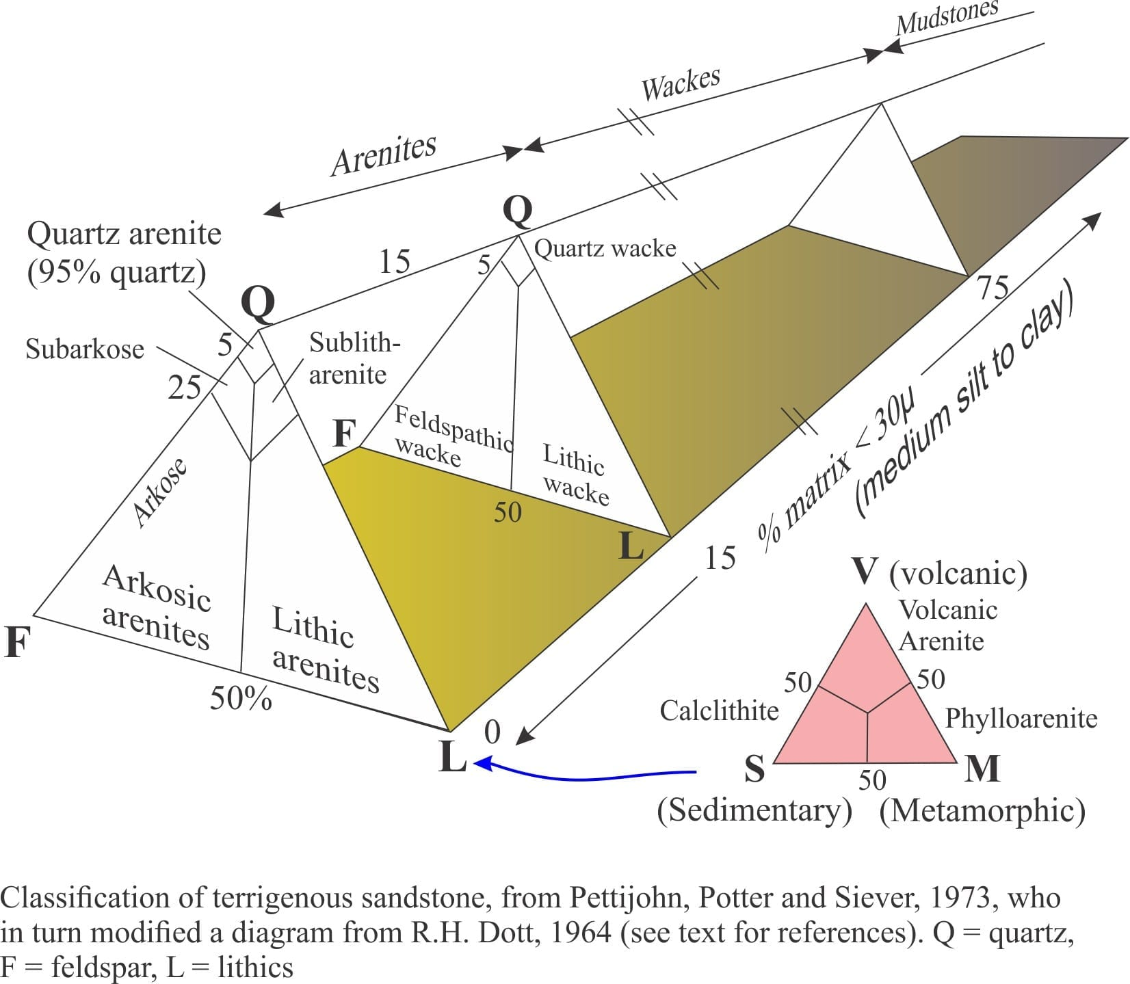
Figure 2.2. Classification of sandstone by Pettijohn, 1973
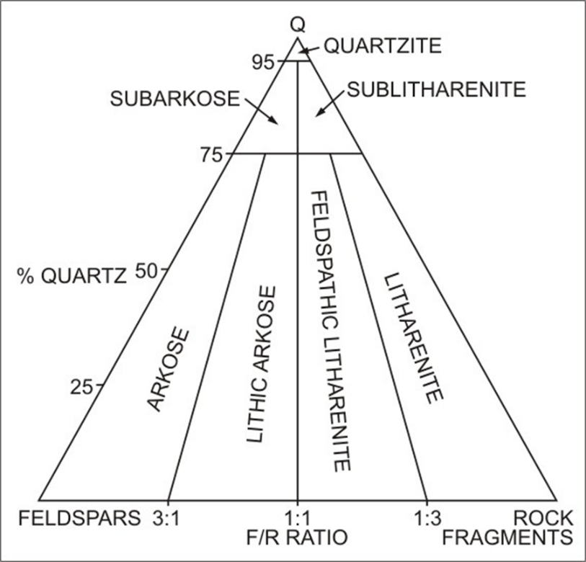
Figure 2.3. Classification of Sandstone by Folk, R.L, 1974.

Depositional Environment
An area of the Earth's surface known as the sedimentary environment is where sediment is deposited. On the basis of its physical, chemical, and biological characteristics, it can be distinguished from other areas. Many places have exposed sedimentary rocks, and these rocks can provide us with information about the sedimentary environment in which they were deposited millions of years ago. We can determine the environment of deposition by examining the rock's physical, chemical, and biological characteristics. These features help us to identify the sedimentary environment in which a rock was deposited. Therefore, the sediment is preserved in the rock record, the types of rocks that will form after lithification. Most of the time, it is possible to compare the environments associated with specific rock types or associations of rock types to their existing analogues. However, sediments were deposited over a longer period of geological time (Balasubramanian & Kalasaiah, 2013). There are three major types of depositional environments they are Continental, Transitional, Marine (Figure 2.4). In continental deposits, it can be further classified into Alluvial, Fluvial and Lacustrine environment. In transitional deposits, it can be classified into Deltaic, Tidal, Lagoonal and Beach environment. In marine deposits, it can be classified into evaporative and glacial environment.
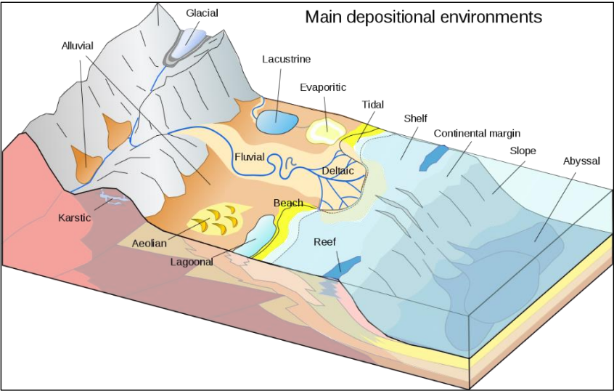
Figure 2.4. The Depositional Environment of sediment.

Transitional environment
The Transitional environments are those environments at or near where the land meets the sea. Transitional sedimentary environments include deltas, beaches and barrier islands, lagoons, salt marshes, and tidal flats. The tidal flats are low-lying areas that are alternately covered by water and exposed to the air each day. The Transition zone between continents and marine environment.

Deltaic
The Deltas are large accumulations of sediment that are deposited where a river empties into a standing body of water. They are one of the most significant environments of sedimentation and include a number of sub environments such as stream channels, flood plain beaches, bars, and tidal flats. The deposit as a whole consists of a thick accumulation of sand, silt, and mud. The deltas are fan-shaped deposits of sediment, formed where a river flows into a standing body of water, such as a lake or sea. The coarser sediment (sand) tends to be deposited near the mouth of the river; finer sediment is carried seaward and deposited in deeper water. The alluvial-deltaic boundary occurs where the river begins to bifurcate and form distributaries.

Estuary
An estuary is the marine-influenced portion of a drowned valley. A drowned valley is the seaward portion of a river valley that becomes flooded with sea water when there is a relative rise in sea level. They are regions of mixing of fresh and seawater. Sediment supply to the estuary is from both river and marine sources, and the processes that transport and deposit this sediment are a combination of river and wave and/or tidal processes.

Lagoonal
The lagoons are shallow, often elongated bodies of water separated from a larger body of water. The Lagoons are bodies of water on the landward side of barrier islands. They are protected from the pounding of the ocean waves by the barrier islands. They contain finer sediment than the beaches (usually silt and mud). The lagoons are also present behind reefs, or in the center of atolls. The lagoons are coastal bodies of water that have very limited connection to the open ocean. The lagoons generally develop along coasts where there is a wave-formed barrier and are largely protected from the power of open ocean waves. A lagoonal succession is typically mudstone often organic-rich, with thin, wave-rippled sand beds.

Marine environment
Marine environments are found in seas and oceans and encompass areas like reefs, the continental shelf, slope, rise, and abyssal plain. Reefs are wave-resistant, mound-like structures primarily composed of the calcareous skeletons of organisms such as corals and certain algae. Today’s reefs are mainly located in warm, clear, shallow tropical waters between latitudes 30ºN and 30ºS. Thick layers of sand, silt, and mud accumulate in various sub-environments, including stream channels, flood plains, beaches, tidal flats, and sand bars. Moving from the beach outward, well-sorted, clean shoreface sandstones build up in the wave-dominated nearshore environment.

Shallow marine clastic
Nearly flat, gentle sloping edge of the continent that extends under the ocean. The regions near the mouths of rivers are usually clastic dominated, because the critters that secrete CaCO₃ tend to have trouble living in muddy water. In closed basins, salinity levels of the water bodies may increase above that of seawater. As a result of excess evaporation concentrating the salts in solution. The Sediments wash off of the continent onto the shelf. The size may range from coarse sand closest to the continent fining to clays. In some areas coral reefs or carbonate mud dominates.

Continental shelf
The continental shelf is the flooded edge of the continent. It is relatively flat (with a slope of less than 0.1º), shallow (less than 200 m or 600 ft deep). It may be up to hundreds of miles wide. The continental shelves are exposed to waves, tides, and currents. They are covered by sand, silt, mud, and gravel. The flooding of the edges of the continents occurred when the glaciers melted at the end of the last Ice Age, about 10,000 years ago. The continental shelf is the shallow ocean surrounding the continent. The depth at the edge of the shelf is usually not more than 100 to 150 meters. Some sand and mud are carried to the edge of the continental shelf via submarine canyons which are like undersea river valleys.

Beach
The beach is most transitional environment and form wase energy to deposited of particle size silt and clay away, and leaving the larger sand particles. Moreover, the silt and clay were deposited in deep marine environment of low energy with term as tidal flats. On the other hand, beaches and barrier island are shoreline deposited.

Deep marine
The abyssal plain is the deep ocean floor. It is basically flat, and is covered by very fine-grained sediment. It consists primarily of clay and the shells of microscopic organisms (such as foraminifera, radiolarians, and diatoms). The abyssal plain sediments may include chalk, diatomite, and shale, deposited over the basaltic ocean crust. In the deep sea, out on the abyssal plains, the depth to the seafloor varies from about 2.5 to 6 km (2500 to 6000 meters) or more below sea level. The abyssal plains receive very little sediment from the continents. The biogenic oozes: Calcareous oozes from deposits of single-cell, microscopic organisms with calcite shells result in finely laminated limestone. The siliceous oozes from single-cell, microscopic organisms with silica shells form finely laminated chert (silica) layers. Furthermore, the limestones indicate warm water; limestone dissolves in cold water. The chert indicates high biological productivity and cool water.

Continental environment
Continental environments are those found on the landmasses of continents. These include alluvial fans, fluvial environments (rivers), lacustrine environments (lakes), aeolian or eolian environments (deserts), and paludal environments (swamps) shown in (Figure 2.5). Sedimentation on continents often starts with clastic materials eroded from mountain ranges. Alluvial fans are composed of poorly sorted debris, primarily boulders and gravel, forming conglomerates. Fluvial (river) environments are characterized by cross-bedded and rippled river sandstones, along with floodplain mudstones (siltstones and clay shales), which may be either parallel or cross-bedded. Lacustrine (lake) environments feature sand deposits at river mouths where they flow into the lake, along the shoreline, and muddy sediments on the deep lake bottom. In continental settings, sediment transport is largely driven by flows that move under the influence of gravity.
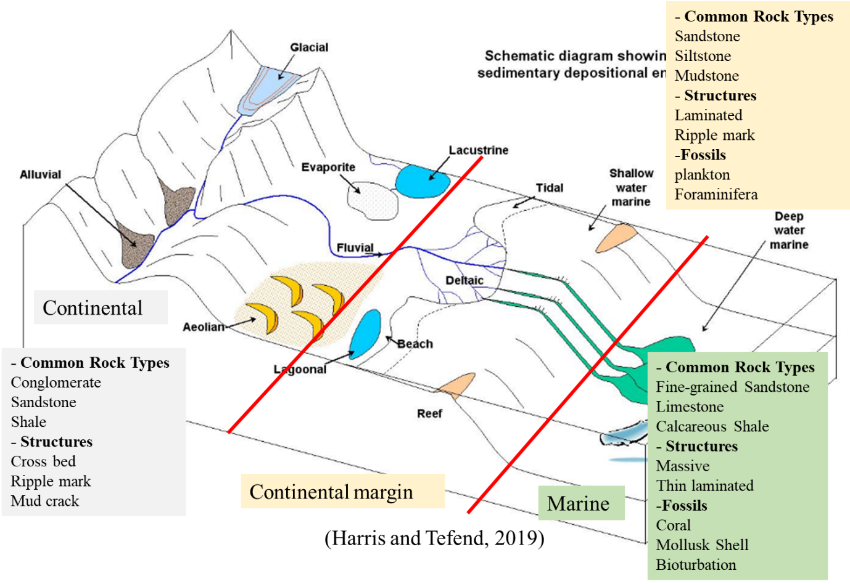
Figure 2.5. Summarize depositional environment (Harris and Tefend, 2019)

Fluvial
Fluvial processes involve the movement of sediment and the erosion or deposition of material on the riverbed. When a river carries a significant amount of sediment, the particles can act as tools to erode the bed (abrasion), while the sediment itself becomes smaller and more rounded (attrition). Sediment in rivers is transported as bed load (larger particles moving near the bed) or suspended load (smaller particles carried in the water), with some material also dissolved in the flow. Fluvial environments encompass braided and meandering river systems, which include sub-environments like river channels, bars, levees, and floodplains. Channel deposits typically consist of coarse sediment, rounded gravel and sand, bars are composed of sand or gravel, levees are formed of fine sand or silt, and floodplains are covered with silt and clay.

Alluvial
Alluvial deposits are generally most widespread in the lower sections of a river, where they form floodplains and deltas. These deposits can also form when a river overflows its banks or when its flow is slowed. Alluvial fans are sedimentary formations typically found at the edges of dry basins, consisting of coarse sediment, poorly sorted boulders and gravel. Fine sand and silt may accumulate near the edges of the fan, often in shallow lakes that can periodically dry up, leading to evaporite deposits. Alluvial deposits include silt, sand, clay, gravel, and significant amounts of organic matter, producing fertile soils, like those in the deltas of the Ganges, Brahmaputra, Mississippi, Nile, and Huang (Yellow) rivers. These regions are also rich in tin ore, gold, platinum, and gemstones.

Eolian
Wind is an effective agent of sorting, selectively transporting sand while leaving gravel behind and lifting fine dust particles high into the atmosphere to be carried over long distances. Windblown sand forms dunes, which are characterized by well-sorted grains and large-scale cross-bedding. Eolian dust sediments, which often lead to the formation of loess and blanket loams, are found in many places. Eolian deposits primarily occur in arid regions (such as sands and loess), but can also be present in other areas. Sand grains are moved by wind through bouncing or rolling, while dust particles can be lifted by rising air currents up to 3,000–6,000 meters and transported hundreds or even thousands of kilometers. When wind energy decreases, sand and dust particles settle out of the air, often accumulating near orographic barriers or being deposited with rain or snow. Deserts typically feature vast areas of sand dunes, where the sand is well-sorted, well-rounded, and polished, without gravel or clay, and cross-bedding is common.

Lacustrine
Lacustrine plains are former lakes that have been filled with incoming sediment. Over time, the water may drain away due to natural drainage, evaporation, or other geophysical processes, leaving the deposited sediments behind. The still waters of lakes allow fine particles such as fine sand, silt, and clay to settle, forming lacustrine deposits. These deposits, often exposed by the elevation of old lakebeds, are well-sorted, lacking coarse materials like gravel or coarse sand, and are characterized by thin layers that indicate annual sedimentation. Lacustrine environments vary widely in size, depth, and water type ranging from freshwater to saltwater and may contain terrigenous, carbonate, or evaporite sediments. Features like mud cracks, wave ripples, laminations, and verves can also be found. The soils left behind from lacustrine deposits can become fertile and productive farmland due to the accumulation of organic-rich sediments, such as algal and bacterial deposits.

Fossil
A fossil is any physical evidence of ancient life, typically dating back to the Holocene or earlier. Distinguishing modern from fossil materials often hinges on their geological context. Even "chemical" fossils, which are organic molecules preserved in rocks, are considered fossils due to their ancient origin. However, marks like splash marks or rill marks are termed "fossil" only metaphorically. Understanding fossils involves examining how biological remains are preserved over time. This process depends on the stability of the organism's materials and the conditions of their preservation. The primary concern is durability rather than physical "hardness" as even delicate structures can be preserved under suitable environmental conditions (Schopf, 1975).
The fundamental conditions for fossilization require organisms' physical remains to be enveloped by a protective sedimentary layer through burial in the Earth's crust. Typically, this occurs in environments such as streams, lakes, inland seas, estuaries, or continental shelves. Certain organic parts, like radiolarian tests and diatom frustules, may even be preserved in deep-sea basin deposits. Apart from rare cases involving wind-blown or volcanic deposits, the sedimentary setting is usually underwater. Over time, these buried remains often become lithified and undergo some degree of alteration by groundwater and weathering during periods of erosion. Fossils undergo diagenesis and early metamorphism, reflecting processes occurring during burial and later stages such as exposure, erosion, and weathering upon excavation. Some types of fossils may also show changes resulting from laboratory preparation. Understanding ancient organisms often relies on comparisons with present-day counterparts, yet interpreting fossil records also depends on our ability to discern geological changes that occurred after burial (Schopf, 1975).

Petrified Wood
The term "petrified wood" is preferred over "permineralized wood". Paleobotanists have traditionally used the latter term to describe fossilized wood, assuming that wood fossilization usually involves the filling of cellular tissues with mineral deposits. However, detailed studies reveal that permineralization is quite rare, with a minimal amount of the original organic matter typically preserved in mineralized wood (Figure 2.6). Petrified wood, a fascinating geological phenomenon, offers insights into ancient forests and environmental conditions. Petrification occurs when the organic material of wood is replaced by minerals such as silica (SiO₂), resulting in a remarkable preservation of the original structure over geological time scales (Ferguson, 1988). This process begins with the burial of wood in sedimentary deposits where it is infiltrated by groundwater rich in dissolved minerals. Over time, these minerals precipitate and replace the organic components, effectively transforming the wood into stone while retaining fine details like growth rings and cellular structure (Ferguson, 1988; Gastaldo et al., 2016). Scientific research on petrified wood extends beyond its geological novelty to provide valuable data on past climates and ecosystems. By analyzing growth ring patterns and stable isotopes within petrified specimens, researchers can reconstruct ancient environmental conditions and seasonal variations (Koufos et al., 2014). For example, variations in growth ring width may indicate periods of drought or favorable growing conditions, offering insights into past climate dynamics (Koufos et al., 2014; Gastaldo et al., 2016). Additionally, petrified wood often contains well-preserved plant tissues and even fossilized pollen grains, providing direct evidence of past vegetation and ecosystem interactions (Ferguson, 1988). Cultural and educational significance also characterize petrified wood. Museums and educational institutions worldwide display specimens that showcase the diversity of ancient flora and the geological processes involved in fossilization (Knoll et al., 2018). These exhibits not only capture public imagination but also serve as educational tools, illustrating Earth’s history and the processes of fossilization. Moreover, petrified wood’s aesthetic appeal—characterized by vibrant colors and intricate mineral patterns has inspired artistic creations and artisanal crafts, further enhancing its cultural value (Knoll et al., 2018). Despite its scientific and cultural importance, petrified wood faces conservation challenges due to illegal collection and commercial exploitation. Efforts to protect petrified wood sites include legislative measures, public awareness campaigns, and collaboration between researchers, land managers, and local communities (Ferguson, 1988; Gastaldo et al., 2016). These conservation initiatives aim to preserve the integrity of petrified wood deposits, ensuring their continued availability for scientific study, education, and public enjoyment (Gastaldo et al., 2016). Petrified wood is classified based on various criteria, including the type of minerals involved in its formation, the anatomical structure of the wood, and the geological processes that contributed to its fossilization. Below are some of the main classifications and types of petrified wood (Mustoe, 2017)
- Classification by mineral composition:
- Silicified Wood: The most common type of petrified wood, where silica (SiO₂) in the form of quartz, chalcedony, or opal replaces the organic material. This type of petrified wood often displays vibrant colors and detailed preservation of the wood's structure.
- Quartz Petrified Wood: Contains microcrystalline quartz, which is durable and often preserves fine details.
- Chalcedony Petrified Wood: Features a variety of colors and patterns due to impurities in the chalcedony.
- Opalized Wood: Rare and contains opal, which can give it a unique, iridescent appearance.
- Calcified Wood: Formed when calcium carbonate (CaCO₃) replaces the organic material. This type is less common than silicified wood and often exhibits a different range of colors and textures.
- Pyritized Wood: Occurs when iron sulfide (pyrite, FeS₂) replaces the wood. This type of petrified wood has a metallic appearance and is usually darker in color.
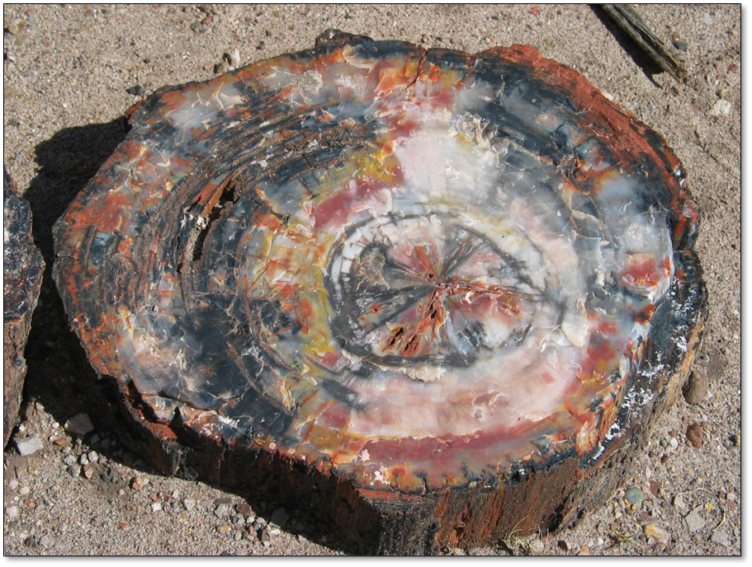
Figure 2.6. Petrified wood. (UCMP fossil types)

Silicification Wood
Silica that initially binds to the wood structure is amorphous but unstable, gradually crystallizing into more stable forms. This transformation involves ongoing polymerization and dehydration, with higher-order forms of opal eventually leading to a thermodynamically stable quartz (Stein, 1982). During this process, layers of silica are deposited, using the wood as a template. Initially, silica adheres to the inner cell walls and fills pits that connect adjacent cells. As permineralization progresses, the cell walls are replaced by silica. For precise replication of the cell structure, a balance between the chemical and biological decomposition of wood and the precipitation of silica is essential. As silicification advances, cellulose degrades, creating more space for silica deposition between cells and within cell wall layers. Lignin, the most decay-resistant compound in wood, continues to serve as a template for structural details. Eventually, cell interiors (lumina), as well as cracks and fractures, are permineralized with silica (Mustoe, 2008).Silicified wood generally contains ≥90 wt.% of silica (Sigleo, 1979). silica mineralization occurs within the compositional range of most stream and ground waters (Sigleo, 1979).

Model of Silicification
Replacement of the cell walls of tracheid and vessels occurred in addition to permineralization, and petrifaction of wood occurred in five stages: 1) wood was permeated by silica solution or colloid, 2) the pores of cell walls were penetrated, 3) progressive dissolution of cell walls built a mineral framework to maintain wood structure, 4) silica deposited in voids, intercellular spaces, and finally cell lumina, and 5) lithification took place, as water was lost and perhaps silica was transformed from one form to another by pseudomorphic replacement and/or repeated solution and recrystallization (Scurf1eld & Segnit, 1984).
There is significant variation, both within and between specimens, in the extent to which taxonomically significant anatomical features of the original wood are preserved in petrification, even when formed from the same type of silica. This duplication can be so coarse that a specimen is barely recognizable as wood or only distinguishable as softwood or hardwood. Conversely, the preservation can be so detailed that it allows for the identification of the helical arrangement of cellulose microfibrils in secondary cell walls or the circular arrangement in pit chambers. Additionally, cell walls may or may not be clearly delineated from cell lumina; the petrification of cell walls may occur with or without partial or complete infilling of pit chambers, canals, intercellular spaces, tyloses, and cell lumina. Within a specimen, cells, even adjacent ones, may differ in appearance, with mineral-filled lumina showing non-uniformity. Furthermore, cell walls may appear swollen, mineral-filled intercellular spaces may be enlarged, and partially or completely separated cells may be rejoined by the mineralization of gaps between them (Scurf1eld & Segnit, 1984).

Modes of Preservation

Cellular Permineralization
There are four distinctly different modes of preservation fossil such as:
Cellular permineralization ("petrifaction"): Permeation of cells and interstices (not replacement) by mineral matrix at or very soon after deposition. Siliceous: Plant remains in chalcedony ("Rhynie", Gunflint) and much fossil wood. Calcareous: Plant remains in coal balls (as in Lancashire or Kansas). Other types of mineralization: Pyritic, limonitic, phosphatic, etc. (Schopf, 1975).
- Process: Early infiltration and permeation of tissues by mineral-charged water with intracellular and interstitial precipitation of colloidal or microcrystalline mineral matter, as suggested below. Examples:
- Siliceous, deposition of colloidal silica forming chalcedony (chert) or microcrystal- line quartz. "Bitter Springs", Gunflint, "Rhynie", "Autum" cherts; Athens County (Ohio) tree ferns. (A second stage of mineralization may induce loss of organic detail and pseudomorphic preservation, as in some of the fossil wood in the western "petrified forests".)
- Calcareous, concretionary deposition of microcrystalline calcite or dolomite in peat of Pennsylvanian age (coal balls). The marine environment immediately following peat deposition is suggested as a source of coal-ball carbonate.
- Pyritic, limonitic, phosphatic, and occasionally other types of permineralization are also known. Pyritic nodules intersecting and per mineralizing plant fossils in the mud that later became Devonian shale have provided important anatomical information. Soft-part preservation of animal fossils occurs in the Hunsrückschiefer of Germany.
- Cryo-preservation, quick-frozen hydrous tissues – permeation of microcrystalline ice (Pleistocene frozen mammoths).

Coalified Compressions
Coalified compressions ("impressions"): softening, collapse and consolidation of nonmineralized tissue in an anoxygenic environment, organic substance eventually becoming coal: Plant mega fossils above coal beds, plant microfossils in shale.
- Process: Unmineralized parts deposited in sediment, softening of cell walls, and collapse of internal cell spaces; loss of gas, moisture and soluble, consolidated altered residues become coaly as deposits become lithified. Distortion (compression) is directional and only in the vertical plane, Splitting commonly yields one coalified part, one impression counterpart, on weathering, coalified substance may be lost or exfoliated, leaving surface IMPRESSIONS on the rock. Examples: The most common type of plant preservation which includes plant mega- fossils in roof shales above coal beds. Cuticles and spore microfossils in shale that show effects of diagenetic alteration and, up to stages of advanced devolatilization, can usually be liberated from unweather sedimentary material by maceration. Fish and probably other animal remain that occasionally have been reported as "bituminized"; also, chitinous carapaces and thecae. Amber, apart from fossils included in it, is coalified, as are all more or less altered resins in mature coals (Schopf, 1975).

Authigenic Preservation
Authigenic preservation ("cementation"): Formation of surface replicas at time of deposition or during very early (soft-sediment) diagenesis, some molds, commonly with interstitial cementation: Ironstone concretions, molds in travertine or limestone, soft-sediment trace fossils.
- Process: Commonly involves very early cementation in soft sediment, usually by iron and carbonate compounds that preserve surface configuration of organic parts. Traces of internal organization usually are lost and most tissues, if originally present, are degraded. External or internal molds and occasionally bulk replacements (pseudomorphs or casts) may result from authigenic preservation. All variations in cementation may occur. Some fossils having very little cementing material are chiefly distinguished by differences in sedimentary texture. The process always results in preservation of structures which originated in soft sediment and some traces of very delicate form can be preserved. Examples: Mazon-type of ironstone concretions, molds in travertine or limestone, soft-sediment trace fossils, microbial fossils in pyrite and in coprolites.

Duripartic Preservation
Duripartic (hard part) preservation: Original parts resistant to oxidation and physical change, also some molds and hard matrix excavations: Skeletal material of animals and some plants or durable trace indications.
- Process: Burial: original parts durable because of resistance to oxidation and physical change. Examples:
- Hard parts of calcium-precipitating algae, coccoliths, etc. (Dasycladaceae, Characeae, Coccolithophoridaceae, etc.)
b) Diatom frustules, radiolarian skeletons ("Modoc" diatomite; radiolarian ooze)
c) Hard parts of most animals:
(1) Original shell or skeletal material preserved (conodonts, shells of phosphatic brachiopods, some well-preserved bones of vertebrates).
(2) Altered or replaced hard parts (siliceous brachiopod and molluscan shells and most vertebrate skeletal remains; invertebrate shells that have been recrystallized)
(3) Original material removed, producing non-mineralized surficial impressions (most abundant in non-cemented deposits that have been subjected to leaching; external and internal molds may be formed if some cementation of matrix accompanies leaching, and pseudomorphs and casts may form if bulk replacement occurs).
(4) Borings or fossil excavations in hard matrix.

Araucariaceae
The Araucariaceae is a family of ancient conifers that today includes three genera, Araucaria, Agathis, and Wollemia, with approximately 40 species. All genera are monophyletic with Wollemia interpreted as the most primitive living genus (Setoguchi et al., 1998). All extant species are evergreen and lack shoot dimorphism. Leaves may be helically arranged or opposite, linear or broad, and cones are typically large. There are only three genera and 41 species worldwide. Araucariaceae are large trees, generally from about 30 m to 90 m in height. The leaves are diverse small, and needle like, to large, broadly ovate, and flattened. The female cones are large and spherical to ovoid. The fossil record of the Araucariaceae suggests that the oldest and geographically most widespread members of the family belong to Araucaria and that at least some species in the family occurred in the Northern Hemisphere (Hill & Brodribb, 1999). Because of the relatively recent discovery of Wollemia, it will be interesting to see if additional araucarian fossils are related to this genus and if so to what extent the geographic distribution of the genus is extended in the geologic record. One interesting anatomical character in members of the Araucariaceae is the presence of undifferentiated exogenous axillary meristems that are buried beneath the periderm in the leaf axils (Burrows, 1999). This situation is unlike that in some conifers that lack buds in the leaf axils and may provide a useful character in distinguishing permineralized fossil araucarian stems. Extant species of Araucaria are divided into four sections Columbea, Bunya, Eutacta, and Intermedia. Del Fueyo and Archangelsky (2002) suggested that Patagonia could have been a center of Mesozoic distribution for the genus, as three of the four sections are represented there, one in the Jurassic (Bunya) and two by the Cretaceous (Colmbea and Eutacta). The presence of a single ovule per ovuliferous scale in the Araucariaceae has been used to suggest affinities with certain voltzialeans. Like the other modern conifer families, however, a consensus on the origin and phylogenetic position of the Araucariaceae is not yet available. The structure of the female cone can be used to recognize the southern families. In the Araucariaceae the female cone scales are spirally arranged with only one relatively large seed per cone scale to which it is fused in the genera Araucaria and Agathis, but free in Wollemia. In all three genera the cone disintegrates at maturity to release the seed. In Cupressaceae all the southern genera belong to the subfamily Callitroideae which has only one monospecific genus, Tetraclinis articulata, north of the equator. The cones in this subfamily are distinct possessing valvate scales in pairs or whorls of three; at maturity these open to release relatively small winged seeds. In contrast the seed-bearing cones in Podocarpaceae are variously reduced and in the extreme may consist of a single seed atop a fleshy, plumlike receptacle comprising the fused remnants of the cone, or with one or two seeds attached to the central axis of the ‘cone.’ This origin of this reduced cone was initially misidentified with the family allocated to the Taxaceae, the yews (TAYLOR, 2009).
- The Araucariaceae family, an ancient lineage of conifers, is composed of three extant genera Araucaria, Agathis, and Wollemia encompassing approximately 40-41 species. These species are exclusively evergreen, retaining their foliage year-round. The trees in this family are notably large, with heights ranging from 30 to 90 meters, making them some of the most towering conifers. Leaf structure in the family is diverse, with forms ranging from small, needle-like leaves to broad, ovate ones. These leaves may be arranged helically or oppositely on the branches, adding to the morphological variation within the family.
- One of the key characteristics of Araucariaceae is the structure of their cones. The female cones are typically large, either spherical or ovoid, and each ovuliferous scale bears a single large seed. In Araucaria and Agathis, these seeds are fused to the cone scales, while in Wollemia, the seeds remain free. Upon maturity, the cones disintegrate to release their seeds, a unique trait that differentiates them from other conifers where cones typically remain intact or open in a less dramatic fashion.
- The family also exhibits distinctive anatomical features, particularly the presence of undifferentiated exogenous axillary meristems, which are buried beneath the periderm in the leaf axils. This feature, absent in some other conifers, provides a useful anatomical marker for identifying fossilized members of Araucariaceae. The fossil record reveals that Araucaria is one of the earliest and most geographically widespread genera of the family, with some species likely existing in the Northern Hemisphere. Additionally, Wollemia is considered a primitive genus based on both fossil evidence and morphological studies, placing it at a unique position within the family’s evolutionary history.
- All three genera in Araucariaceae are monophyletic, indicating they share a common ancestor. However, the origin and phylogenetic relationships of the family remain debated. The family’s cone structure, which disintegrates at maturity, contrasts with the cones of related families such as Cupressaceae and Podocarpaceae, further distinguishing Araucariaceae in terms of reproductive morphology. This combination of ancient lineage, unique anatomical features, and distinctive reproductive strategies make Araucariaceae a notable family within the conifer order.

Gymnosperms conifer
Gymnosperms were dominant in the Mesozoic Era (about 252.2 million to 66 million years ago), during which time some of the modern families originated (Pinaceae, Araucariaceae, Cupressaceae). Although since the Cretaceous Period. gymnosperms have been gradually displaced by the more recently evolved angiosperms, they are still successful in many parts of the world and occupy large areas of Earth’s surface. Conifer forests, for example, cover vast regions of northern temperate lands, and gymnosperms frequently grow in more northerly latitudes than do angiosperms. Conifer leaves are always simple and often small and scalelike or needlelike (Abies, Picea, Pinus), though some have a broad blade (Araucaria, Agathis). Bald cypress (Taxodium), larch (Larix), and dawn redwood (Metasequoia) are deciduous, but most conifers are evergreen. The stems of conifers are characteristically woody with a dense mass of secondary xylem. They are usually branched, with basal branches dropping off as the stem elongates, resulting in a main stem that is often tall and straight. The wood is simpler than that of angiosperms; it consists primarily of elongated tracheid (water- and mineral-conducting cells) in the xylem and vascular rays in the phloem that store materials and provide for lateral conduction. The growth tissue of the stem and branches, known as the vascular cambium, contributes more xylem each growing season, forming concentric growth rings in the wood. Tracheid produced by the vascular cambium early in the growing season are larger, and the walls thinner, than those formed later in the growing season. This results in the characteristic light and dark bands of wood. Some conifers have additional cell types, such as fibers and axially elongated xylem parenchyma cells that store food. The wood of gymnosperms is often called softwood to differentiate it from the hardwood angiosperms (Figure 2.7).(Carvalho et al., 2013).
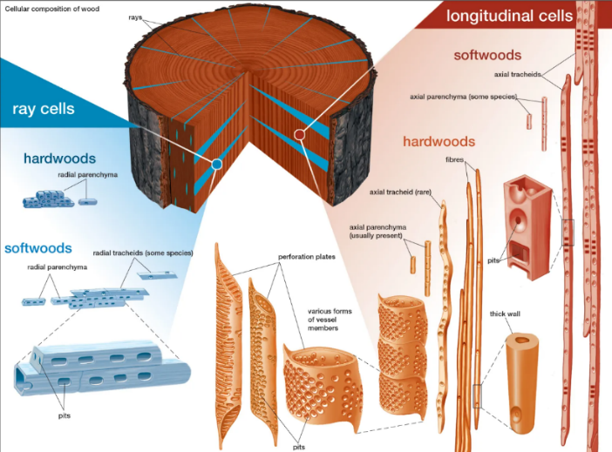
Figure 2.7. Types of cells present in hardwoods and softwoods.

Taxonomy of vascular plants
In the sub-kingdom of vascular plants for seeds producing devices into two class including, Gymnospermae (non-flowering and cones) and Angiospermae (Flowering plants and seed). For the class of Gymnospermae count into four extant divisions such as, Cycadophyta, Ginkgophyta, Gnetophyta, and Coniferophyta. To the divisions of coniferophyta cover into seven families including, Pinaceae, Araucariaceae, Podocarpaceae, Sciadopityaceae, Taxaceae, Cephalotaxaceae, and Cupressaceae. Most of conifers are evergreens, their leaves are staying green throughout the year. Conifers come in a variety of sizes, from yews and junipers to huge trees. They are found all across the planet, and they frequently favor high-elevation areas and colder climates over temperate ones. Conifers are most abundant in cool temperate and boreal regions, but they can also be found in warmer areas, including tropical mountains. Conifers also predominate in mid-latitude mountain systems, which have the richest north temperate conifer forests. Warm temperate climates are found at moderate elevations and lower latitudes. For the classification of the tree truck of Conifers have simple characteristics like a palm-like tree habit and an unbranched stem. The petrified wood has found only stem and truck in the mountain ring. The fossilized wood is round 3.5 meters in length and 0.8 meters in width. It may go deep into the conifer depending on the species and Southeast Asian weather (Chao et Herbarium, 1999).

METHODOLOGY

Research Framework
The aim of this study to characteristic the paleo-environment, based on Petrography by thin section, XRF (x-ray fluorescence), SEM (scanning electron microscopic) analysis. The study area was selected regarding lithological information and previous researched. After site selection, rock formation was identified by physical properties and sampled for laboratory experiments (Figure 3.1).
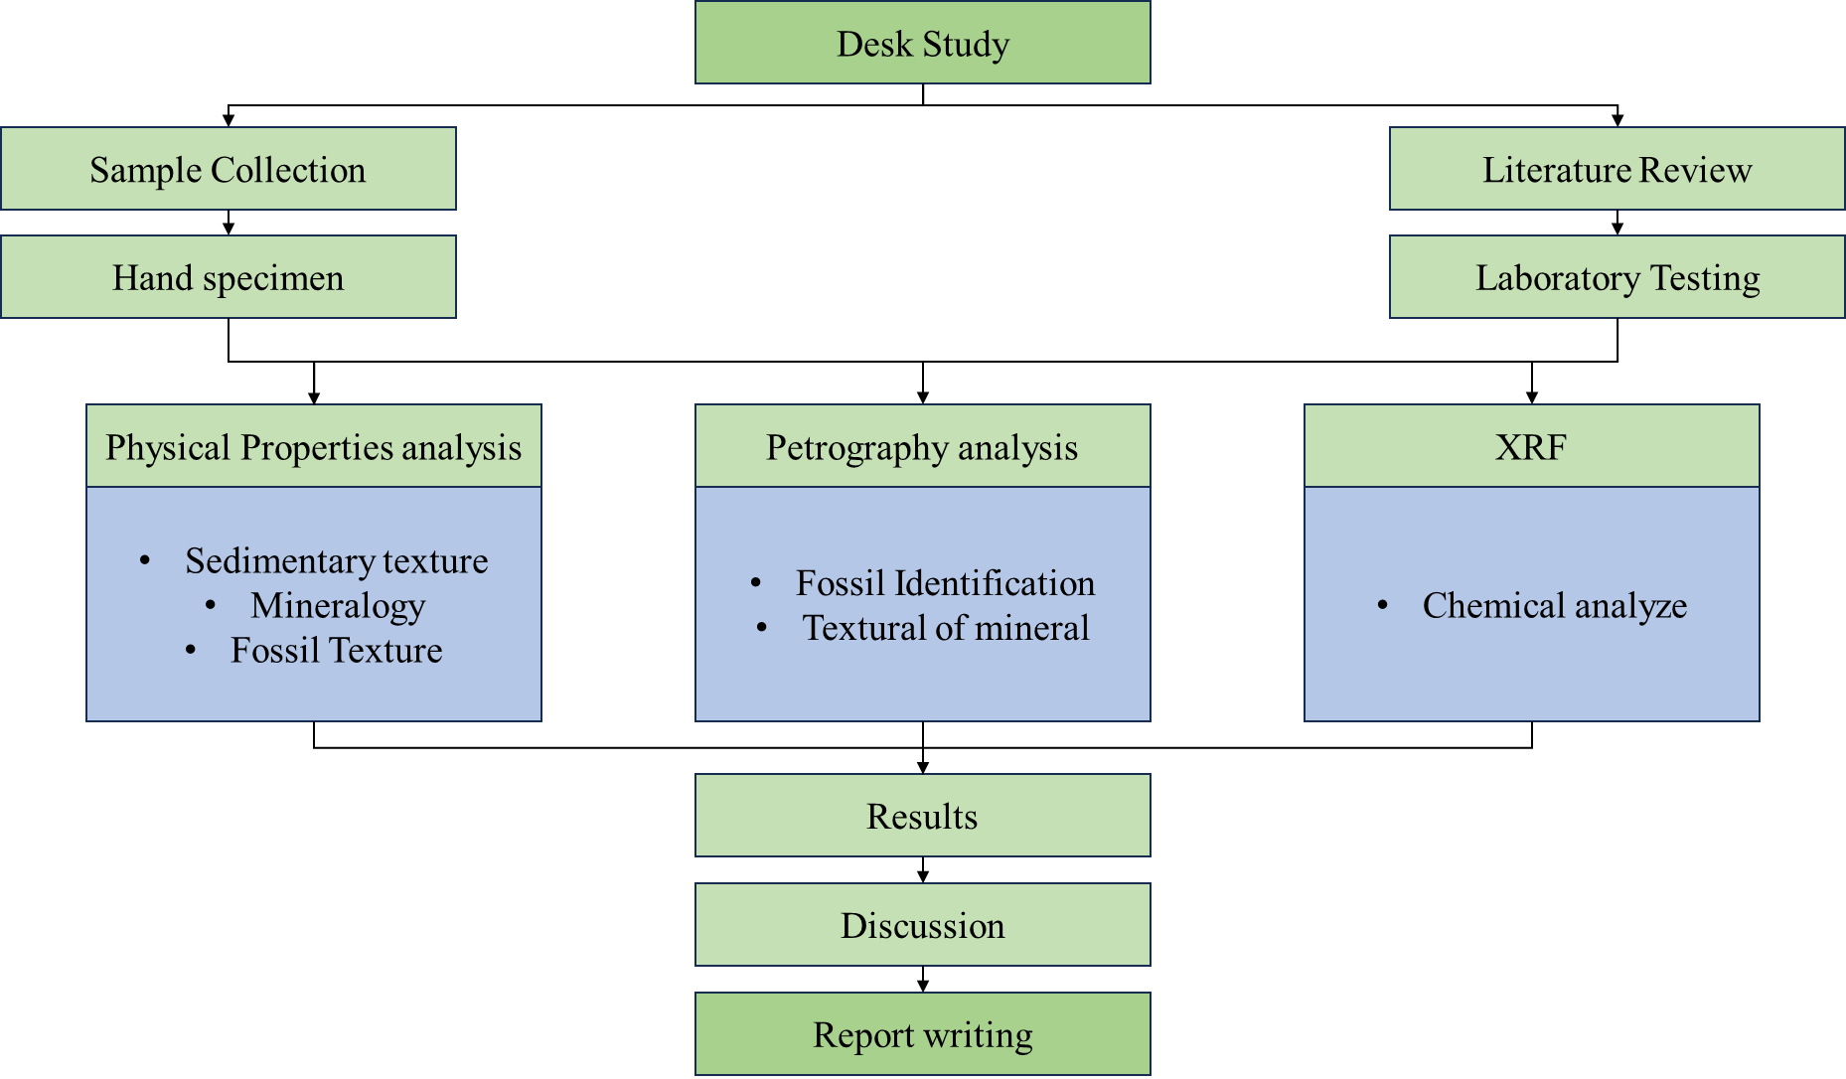
Figure 3.1. Research Flow Chart

Fieldwork
Field work was carried out in Lom phat district, Ratanakiri province in order to refine the local geological map and to collect a systematic suite of representative rock samples for laboratory test. The field survey method was designed around the difficulty of research for fossil. During field investigation a large fossilized tree trunk was exposed due to a collapse from the eastern side, sloping from the south toward the west and leaning toward the north. The trunk is supported by stone, causing the upper part to be elevated and extending outward. The layer of sample H1 is relatively high in elevation, which suggests that conditions capable of fossilizing a tree trunk require burial in a layer of soil where oxygen cannot permeate, occurring over tens of thousands or even hundreds of thousands of years. Based on the geologist of General Department of Local Community Ministry of Environment at Douer Mountain where it is located around 1 kilometer from the excavation pit H1 consider it as sandstone which is sample H1 was erosion of petrified wood fossil. After field survey for rock outcrop was photographed from various angles with scale, GPS location metadata. Structural measurement, character of structural feature, fossil types and mineralogy. Finally, the samples were characterized in situ before being careful get it and labeled. All the samples were taken for petrography (Thin section), XRF (X-ray fluorescence) and SEM (Scanning Electron Microscopy) analysis at as the laboratory of Faculty of Geo-Resources and Geotechnical Engineering in Institute of Technology of Cambodia.
To conduct the field observation and mapping, geologist need numerous items for the field: map, Global position system (GPS), geological hammer, compass, hand lenses, sample bags, field notebook, pen, pencil, eraser, clinometer, camera, acid bottle, first aid kit and safety with comfort clothes. Moreover, we should add mobile phone and boots for efficiently fieldwork. Observations of the sample site should take (Figure 3.2). These should include:
- GPS is utilized for point the coordinates
- Location (Latitude, Longitude and Elevation)
- Types of samples contain fossils (Ammonite, petrified wood, etc.)
- Take all the photo with outcrop
- Draw the important structure in notebook (Sketching)
- Checking all the equipment before and after finish field work
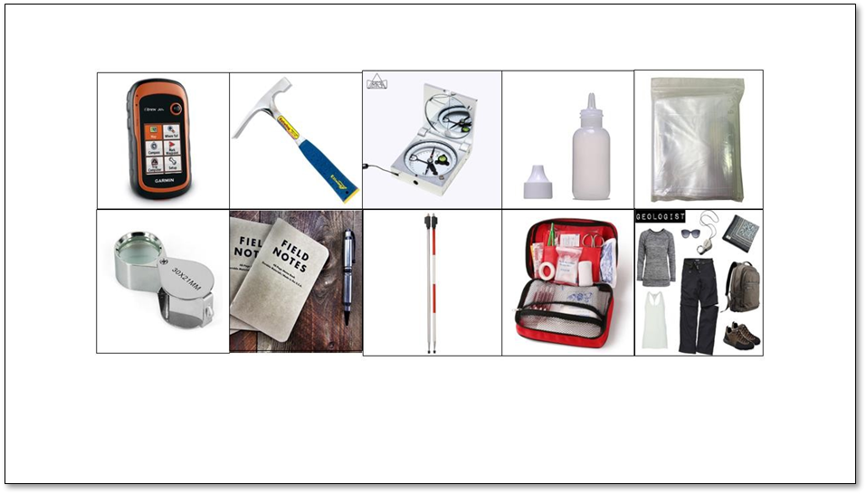
Figure 3.2. Fieldwork Equipment

Site excavation
Materials used in this study include pieces of fossil wood taken from the 56 petrified wood excavation pits in Lom Phat area WGS1984(720755-1482844) are shown in (Figure 3.3). The samples were labeled with number prefixed by Alphabet, arranged from A (1) to N (-3) in accordance with the excavation pits 1 to pits 56. Sample were collected from AC2, H1 and J3 pit. The samples were taken back to the laboratory for testing. Sample at J3 pit (petrified wood) were cut into three sections, transverse, tangential and radial plane and cleaned with the water to remove dust and mud out of the sample. Next step takes a photo of sample specimen after cutting and cleaned. The three sample were cut for thin section were studied under the microscope, Fossil wood cell structures of the vessels, rays, axial parenchyma, and fibers from the three thin sections were then described. All laboratory processes were carried out at the Faculty of Geo-resources and Geotechnical Engineering.
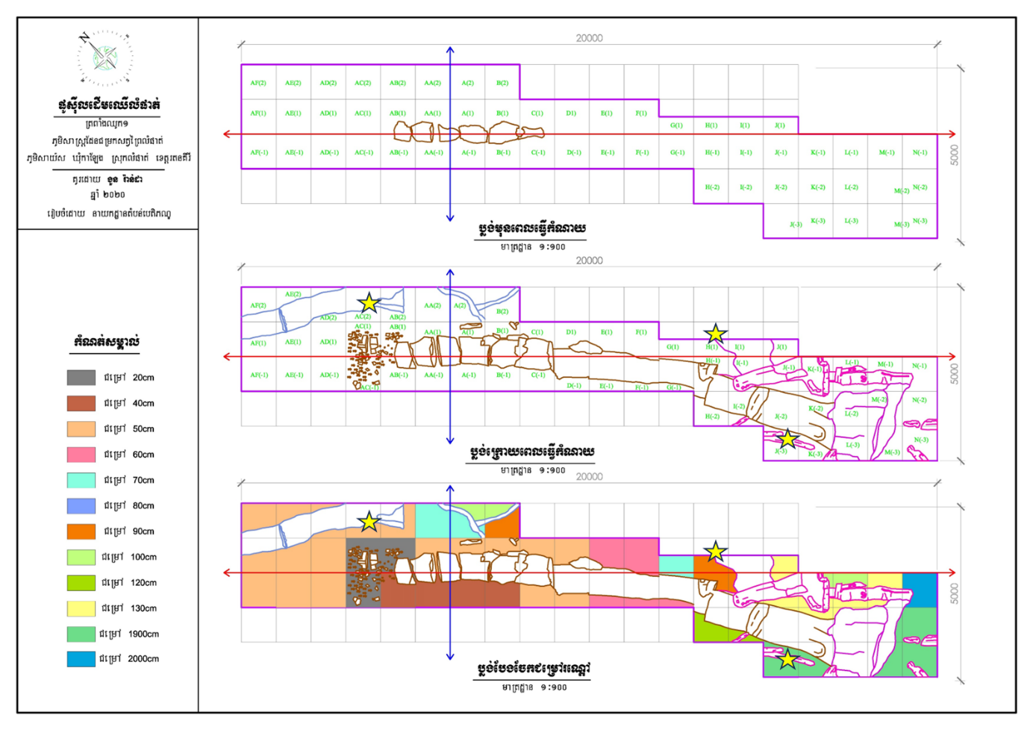
Figure 3.3. Petrified wood excavation site at Lom Phat area (Department Heritage Park, General Department of Local Community Ministry of Environment, Cambodia, 2020)

Laboratory Work

Hand Specimen Analysis
Hand specimen is a method to identify physical properties of rock sample. Its necessary tools acquired for physical properties analysis (Figure 3.4)including:
- Hand lens: used to identify on characteristic texture grain of mineral such as grain size, grain shape, grain sorting, grain rounded.
- Grain size ruler: applied to defined size grain of mineral.
Hand specimen analysis was identified at following part:
- Grain size, shape and sorting
- Color
- Mineral composition
- Structure
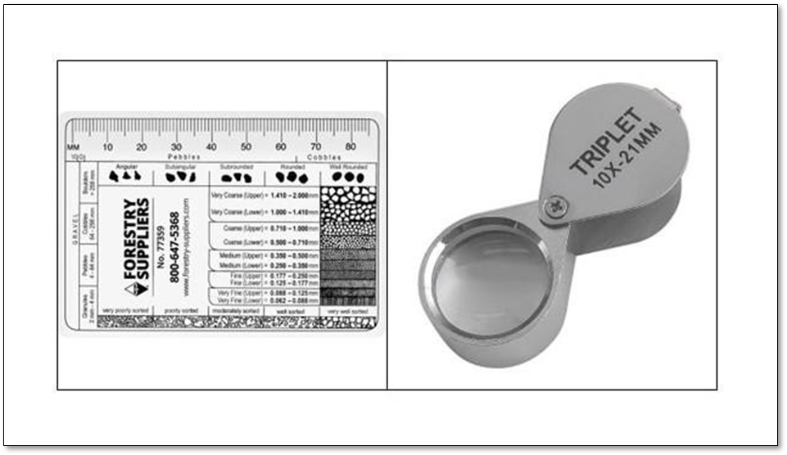
Figure 3.4. Hand specimen equipment

Petrography Analysis
The petrographic analysis aims to study rock type under a polarizing microscope. This analysis is useful to observe and identify the aggregate of minerals, textures, associated mineral, primary and secondary minerals, and their paragenetic relationship. The samples with a standard thickness of 30μm were prepared to analyze under the transmitted light microscope.
Two types of transmitted light Plane polarized light (PPL) and crossed polarized light (XPL), were interchangeably used. The geological society of Japan's Michel-Levy chart was used to determine interference color. The optical properties of minerals were investigated in each light situation. The geological society of Japan's Michel-Levy chart was used to calculate interference color and birefringence.
Samples were petrographically thin-sectioned at the Geo-resources and Geotechnical Engineering Faculty lab at the Institute of Technology of Cambodia. Polarizing Microscope ECLIPSE Ci POL was used to evaluate all materials in cross-polarized and plane-polarized light.
- Sample Preparation for Thin Section
- Thin-section preparation equipment
- Large-scale rock-cutting machine: Reducing the large-size sample
- Small-scale rock-cutting machine: Reduce the size of the rock to a size that is appropriate for the technique preparation procedure.
- Grinder wheal: This smoothness and flattens the surface of the cut sample.
- Polishing glass plat: Make the sample smoother and flatter than the wheal grinder.
- Ultrasonic cleaner machine: Removing tightly adhered contaminants from intricate items with blind holes, cracks, and recesses.
- Electronic hot plate: heat the sample's access water and dehydrate moisture out of the sample.
- Ethanol: For cleaning (dust particles, dust remains…)
- Safety shirt and glasses: Apply for a low-risk, accident-free process.
- Petropoxy Resin 154, Curing agent: Glue Mixture
- Slice glass: Attach with the rocks sample which requires in thin section, shown in (Figure 3.5)
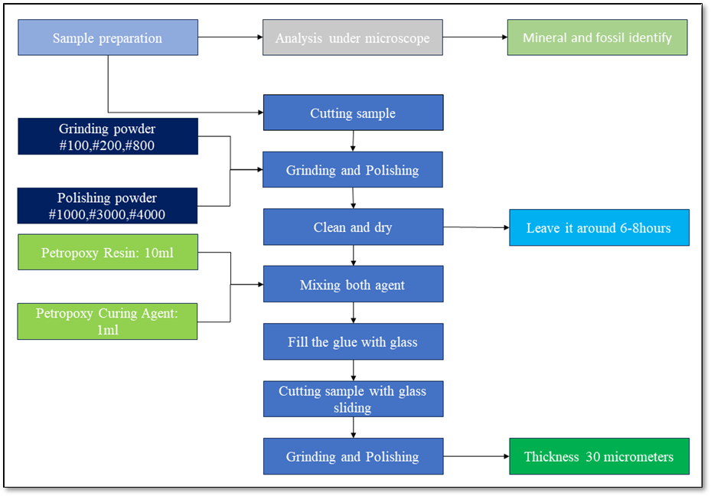
Figure 3.5. Thin Section procedure.
- Step 1: We should select fresh rock samples for cutting by large cutting machine (for large samples) into small sizes and then use a precious cutting machine to reduce the size of samples to fit with the glass (Figure 3.6 A&B).
- Step 2: Take cutting samples to grinding with carborundum grit sizes #100, #220, and #800. Then samples need to be polished with glasses plate and powder grit sizes #1000, #3000, and #4000. After one to other steps, clean samples with an ultrasonic cleaner (Figure 3.6 C)
- Step 3: Putting samples on the heat plate may be at temperatures of 80°C about 8h, then attached with a glass slice of petropoxy Resin 154 mixed with curing agent in a 10:1 ratio respectively. To keep samples glass slices on the same heating plat for about 6h or overnight (Figure 3.6 D).
- Step 4: Bring an attached glass slice sample to cutting and grinding it with a grinding precision machine to ~0.05mm thick, then clean it with an ultrasonic cleaner machine and polish with polishing glass plate #1000, #3000, and #4000 until thickness~0.03mm. Generally, the thickness of the sample depends on the quartz color becomes white and grey color under a microscope.
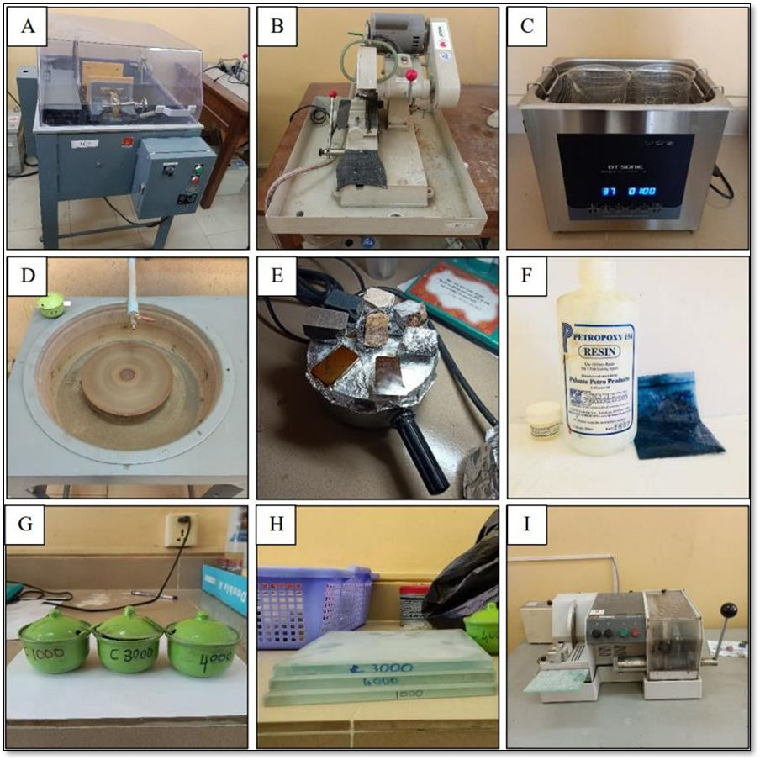
Figure 3.6. The equipment is used in thin-section preparation. (A). Large scale rock cutting machine, (B). Small scale rock cutting machine, (C). Grinder, (D). Ultrasonic cleaner machine, (E). Polishing glass plate, (F). Petropoxy resin 154 and Curing agent, (G).

Point counting method
For using the Fiji program to grid on the thin section image and count as shown in Figure 3.7 the point counting method is used to determine the percentages of the main components of the samples. All of the grids that we have split rely on the nature of the rock samples.
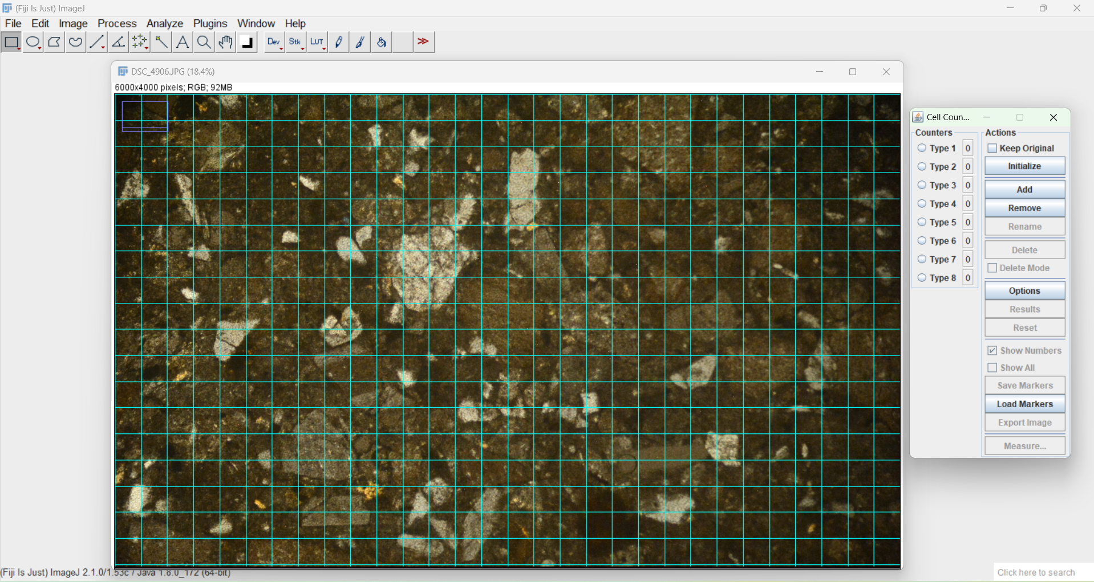
Figure 3.7. Fiji program for point counting

X-ray fluorescence (XRF) Analysis
XRF is a non-destructive elemental analysis method for solids and liquids. The phenomena are extensively used in element and chemical analysis. The purpose of an XRF lab lecture is to identify and determine the chemical compositions of rocks.
The method is based on the energy properties of the atoms present in the samples. Atoms were ionized when they were subjected to short wavelength x-rays with energies greater than their ionization potential. The removal of one electron resulted in an unstable atomic structure that had to be compromised by electrons dropping from higher orbitals into lower orbitals. This falling produced energy in the form of a photon, equivalent to the energy difference between two orbitals (Figure 3.7). We will learn how to properly prepare our sample for this lab, as well as how to analyze and analyze the results.
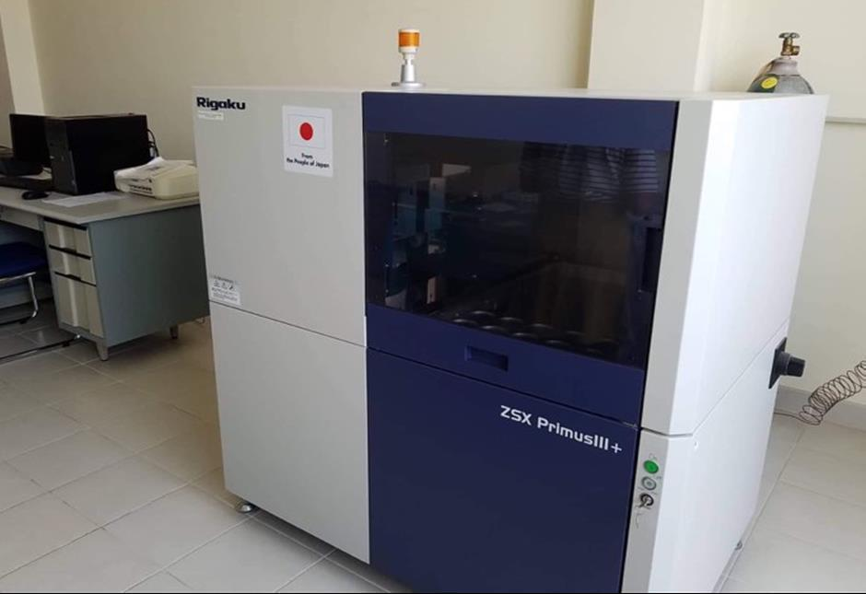
Figure 3.8. X-Ray Fluorescence Machine (XRF)
- Samples preparation for X-Ray Fluorescence
In this part, you will take an intriguing sample and identify and check information about it based on its physical features.
- Before using any equipment, clean it with quartz sand to minimize contamination.
If the sample is particularly huge, we must break it down using a hummer, which may break it down into little pieces of sample.
- Place sample into iron mortar and break it again to obtain a smaller than piece of sample (using iron motor since many samples include iron)
- After that, take sample and grind it using agate mortar to get powder or using vibrating simple mill to acquire sample powder
- If we use a basic vibrating mill to grind our sample, we must first remove the sample from the iron mortar and then place it in the mill.
- If we use a vibrating simple mill to grind our sample, after taking a sample from an iron mortar, we place it in mortar machine sample containers and place the mortar machine sample containers in the grinding machine (Vibrating Sample Mill), and we run the machine for 6-9 minutes for limestone or longer depending on the hardness of our sample.
- For power diffraction, take 6.5 g or 7 g each sample.
- The sample power was obtained and forced into the ring for the power diffraction sample.
- If palletization is problematic, another option is to use a forming agent called "binder."
- We provide two kinds of rings: aluminum rings and PVC rings. Using it based on sample preparation and sample type.
- Use the pressing machine to press the sample that has previously been produced.
- Record the mass and a little compaction to ensure that you have a good sample for testing.
- Pressing the sample with 10 KN for 2 minutes and 18 KN for 1 minute.
- After pressing, knock the sample to ensure that it is suitable for processing in the machine.
- Prepared sample and placed it in cylinder dice to verify our sample.
- Place the sample in the XRF machine and ensure that it plates.
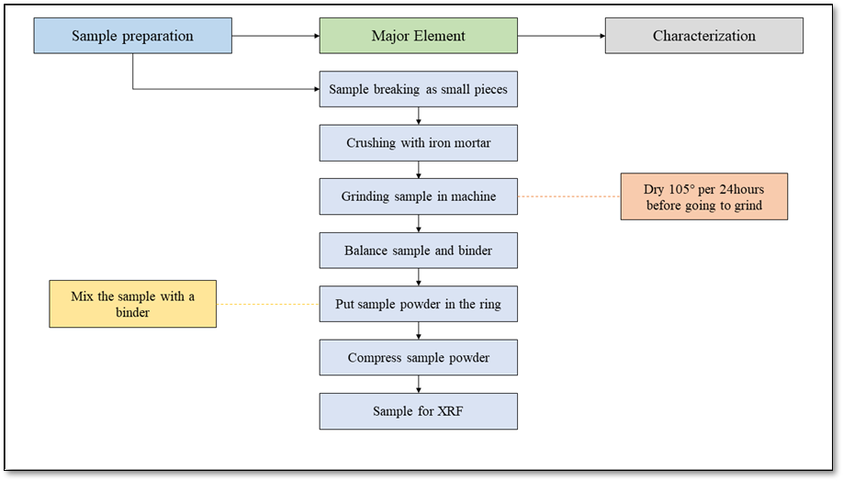
Figure 3.9. X-ray fluorescence procedure

- Equipment and material
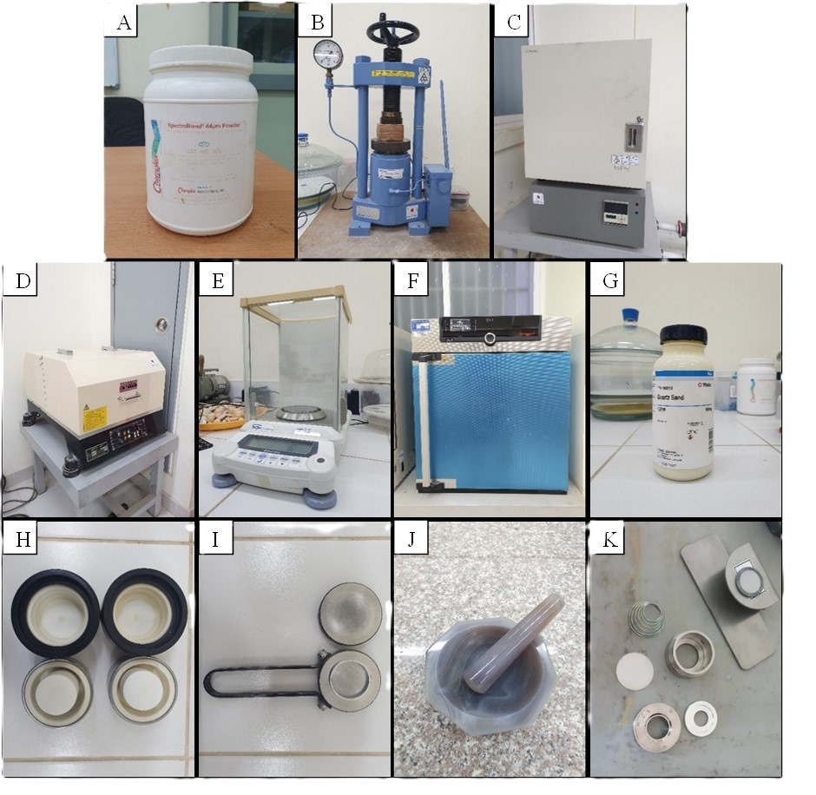
Figure 3.10. A. Binder, B. Compressor, C.LOI Machine, D. Vibrating sample mill, E. Weight scaler, F. Drying oven, G. Quartz Sand, H. Miller sample container, I. Compression holder and Aluminum ring, J. Agat Mortar, K. Cylinder type dices and verity.

RESULTS AND DISCUSSION

Results

Hand specimen
Sample ID | Photo | Description
J3-C | 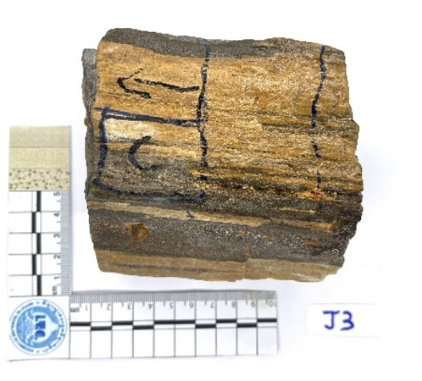 | Types: petrified wood (Araucariaceae family)  Color: greyish, light brown  Grain size: fine grain, mud supported  Excavated from block J3 at depth 1900centimeters
J3-K | 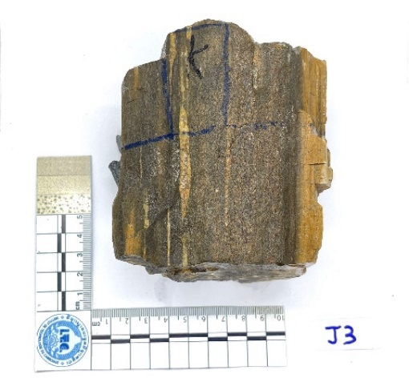 | Types: petrified wood (Araucariaceae family)  Color: greyish, light brown  Grain size: fine-medium grain, mud supported  Excavated from block J3 at depth 1900centimeters
J3-P | 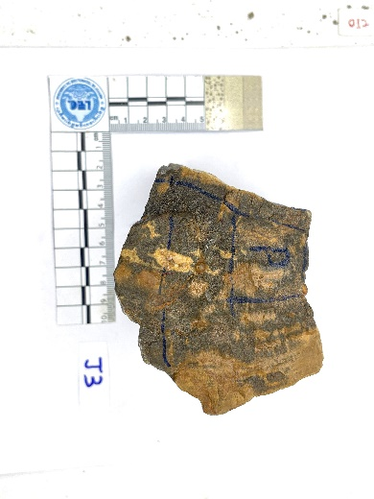 | Types: petrified wood (Araucariaceae family)  Color: greyish, light brown  Grain size: fine-medium grain, mud supported  Excavated from block J3 at depth 1900centimeters
J3-1 | 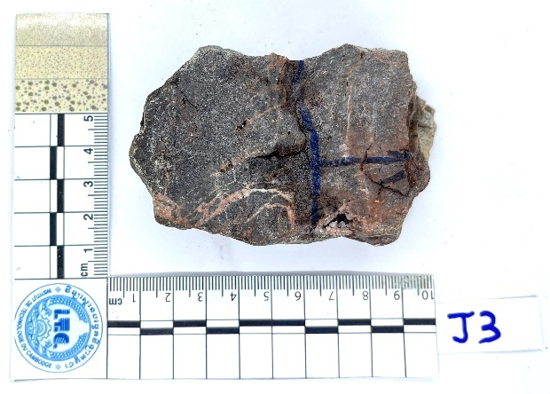 | Types: petrified wood (Araucariaceae family)  Color: greyish, red  Grain size: fine grain, mud supported  Excavated from block J3 at depth 1900centimeters
J3-2 | 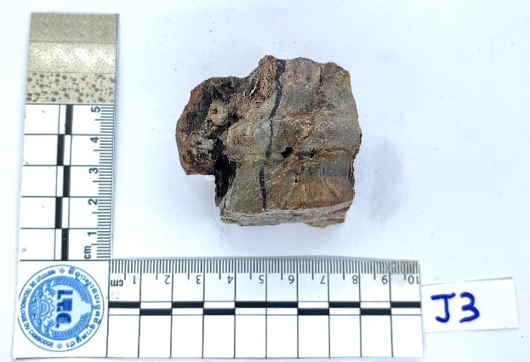 | Types: petrified wood (Araucariaceae family)  Color: greyish, brown  Grain size: fine grain, mud supported  Mineralization: quartz microcrystalline  Excavated from block J3 at depth 1900centimeters
H1 | 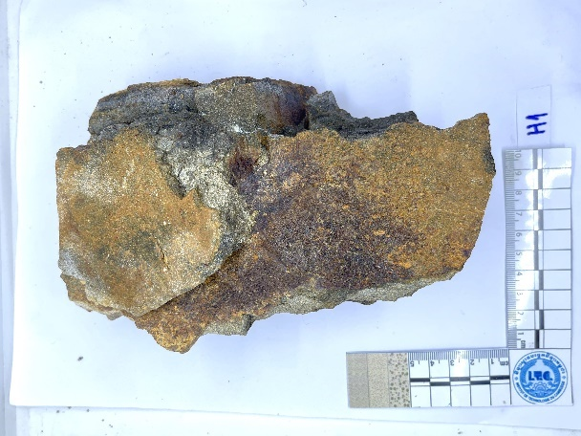 | Rock types: Sandstone  Color: brownish, grey  Grain size: fine-medium grain  Mineralization: quartz, plagioclase, fossil?  Excavated from block H1 under petrified 1meter
AC2 | 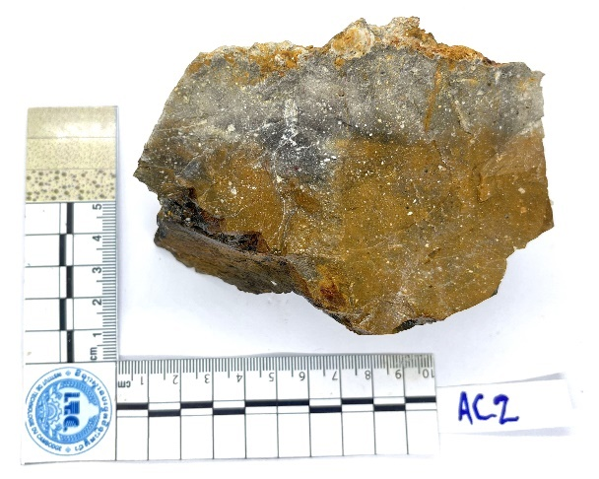 | Rock types: sandstone  Color: brownish, grey, red  Grain size: fine-medium grain  Moderately weathering  Excavated from block AC2 at depth 50centimeters

Thin section analysis
Based on hand specimens and microscopic analysis, samples taken from 3 blocks such as H1, AC2 and J3 which divided in 5 small samples more. There are numerous types of minerals, including quartz, plagioclase, muscovite, feldspar, rock fragment (Lithic), micro quartz and textural of petrified wood. There were 7 samples collected for do petrography (thin section), which is conducted for rock type and petrified wood analysis.

Petrified wood analysis
Under microscope, sample J3-C Tangential section showing which consists of quartz filled in. In this sample mostly composed of quartz which is black, gray and white color in cross-polarized light (XPL). low relief, low birefringence, transparent in plain polarized light (PPL), wood cell which is circle shape, fiber is black spot and ray run horizontally from the cambium towards the center of the trunk. (Figure 4.1).
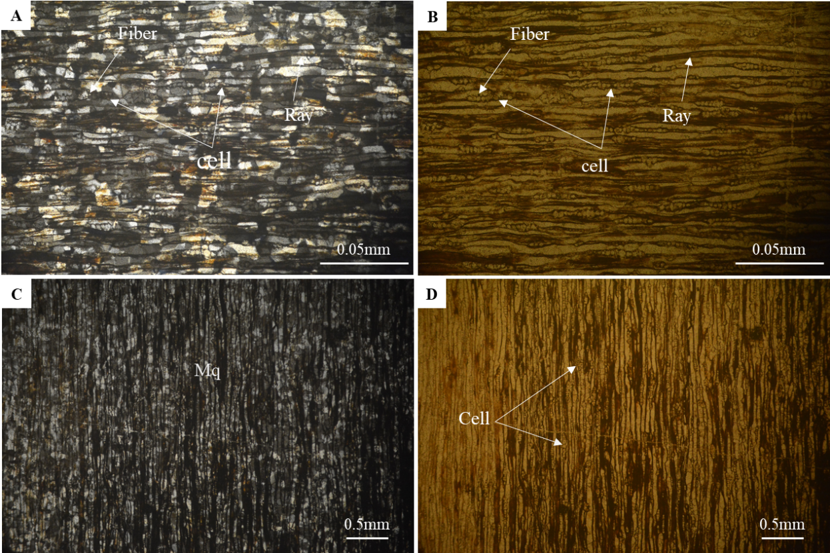
Figure 4.1. A-D) tangential section- wood cell, elongate ray, fiber and Mq=microcrystalline quartz which A&C showing in XPL, B&D showing in PPL.
Under microscope, sample J3-P transverse section showing composed of quartz filled it in. Microcrystalline quartz in a thin section and is typically low relief, low birefringence, transparent in plain polarized light (PPL), but colors black, white, and grey in cross-polarized light (XPL). Ray showing a horizontal line, (Figure 4.2) Resin ducts are long intercellular spaces lined with plastid-enriched epithelial cells that produce and secrete resin into the duct lumen, where it is stored under pressure and wood cell which is circle shape.
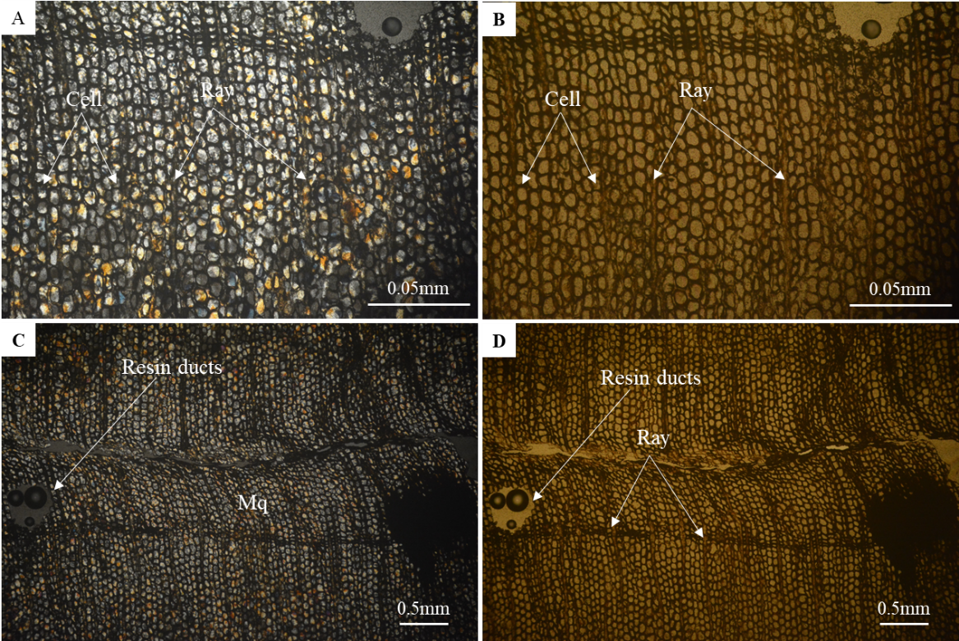
Figure 4.2. A-D) Transverse section- Wood cell, Ray, Resin ducts and Mq= microcrystalline quartz, which A&C showing in XPL, B&D showing in PPL.
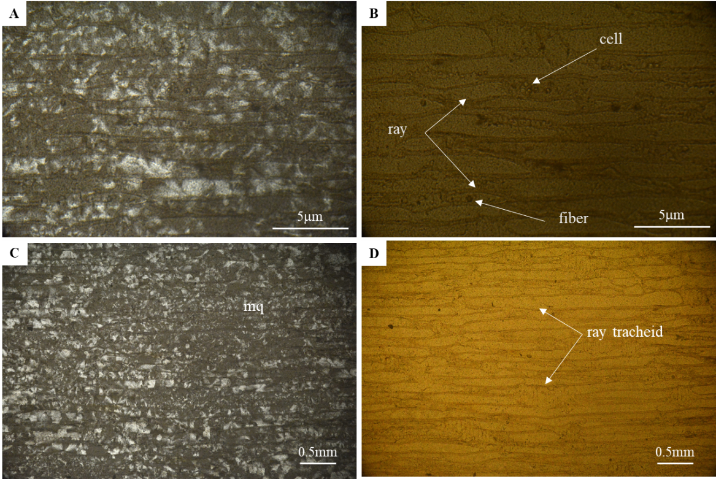
Figure 4.3. A-D) Radial section- wood cell, Ray tracheid, fiber and Mq=Microcrystalline quartz, which A&C showing in XPL, B&D showing in PPL.
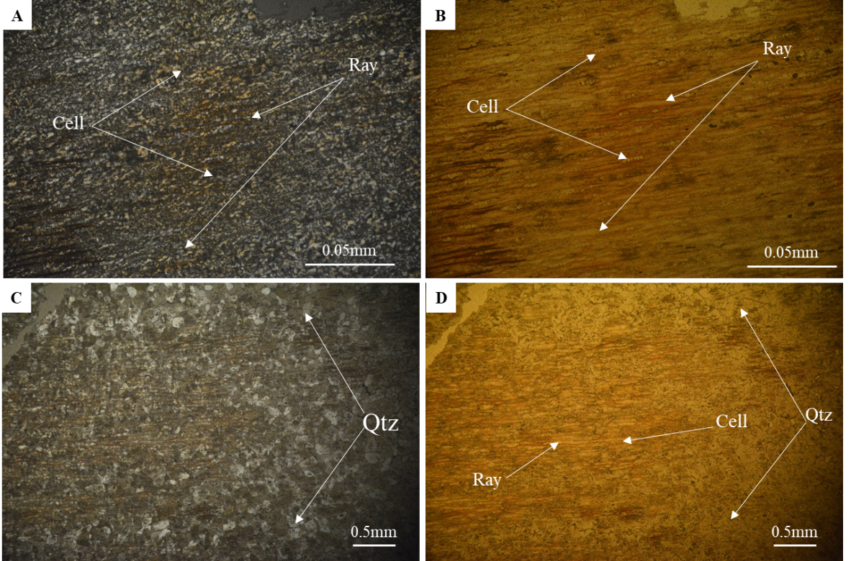
Figure 4.4. A-D) tangential section- early wood with large, thin-walled cells, Ray and Mq=Microcrystalline quartz, which A&C showing in XPL, B&D showing in PPL.
Under microscope, sample J3-K radial section (Figure 4.3)showed wood cell with circle shape, tracheid ray which is elongate and wood cell were in it, ray-tracheid are in the cross-field in communication by means of very small bordered pits. Fiber having black spot and microcrystalline quartz in a thin section and is typically low relief, low birefringence, transparent in plain polarized light (PPL), but colors black, white, and grey in cross-polarized light (XPL).
Under microscope, sample J3-1 with tangential section (Figure 4.4) showing early wood with large, thin-walled cells, ray run horizontally from the cambium towards the center of the trunk and quartz in microscope which is black, gray and white color in cross-polarized light (XPL). low relief, low birefringence, transparent in plain polarized light (PPL).
Under microscope, sample J3-2 with tangential section (Figure 4.5) showing late wood with small, thickwalled cells, ray run horizontally from the cambium towards the center of the trunk and microcrystalline quartz in microscope having small grain size which is black, gray and white color in cross-polarized light (XPL). low relief, low birefringence, transparent in plain polarized light (PPL).
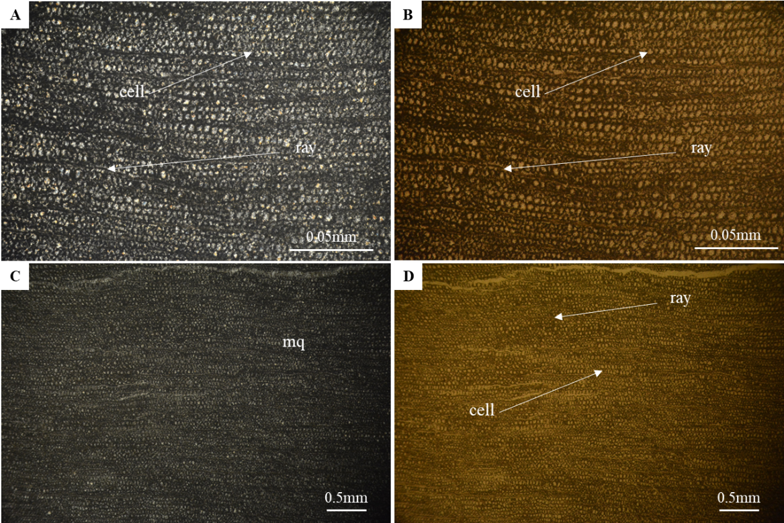
Figure 4.5. A-D) tangential section- late wood with small, thick-walled cells, Ray and Mq=Microcrystalline quartz, which A&C showing in XPL, B&D showing in PPL.

Environmental analysis of Sandstone
By hand specimen analysis of sample H1 showing brownish-gray color, fine-medium grain, moderately weathering, this sandstone is often poorly sorted. Sample H1 have been analyzed by thin section as sandstone. This sandstone mainly composed of quartz, K-feldspar, plagioclase, rock fragment (lithic), muscovite and matrix. Even so, sample AC2 by hand specimen analysis showing brownish, grey, red, fine to medium grain size texture, moderately weathering, grain texture often poorly sorted. Sample AC2 have been analyzed by thin sections as sandstone. This sandstone consists of quartz, k-feldspar, plagioclase and iron oxide (limonite).
Sample H1 have been analyzed by thin section as sandstone. This sandstone mainly composed of quartz, K-feldspar, plagioclase, rock fragment (lithic), muscovite and matrix.
Under the microscope, sample H1 consists of quartz, plagioclase and fossil. which is Quartz in a thin section and is typically low relief, low birefringence, transparent in plain polarized light (PPL), but colors black, white, and grey in cross-polarized light (XPL). Plagioclase is typically white and gray and it has twinning in cross-polarized light (XPL) and polarized (PPL), Muscovite in plain polarized light (PPL) is typically moderate relief, colorless and only have one direction, but for cross-polarized light (XPL) is anisotropic which inference color in order III-IV, shown in Figure 4.6.
Under the microscope, sample AC2 composed of quartz, plagioclase and iron oxide (limonite). Which Quartz in a thin section analysis is typically low relief, low birefringence, transparent in plain polarized light (PPL), but colors black, white, and grey in cross-polarized light (XPL). Plagioclase is typically white and gray and it has twinning in cross-polarized light (XPL) and polarized (PPL) and iron oxide or Hematite is usually opaque, but can be deep-red brown with interference colors are very high but masked by red-brown colors, show in Figure 4.7.
After using point counting method (Fiji program Figure 3.7) samples were analyzed by petrography. Sample H1 mainly composed of quartz (17.82%), feldspar (25.58%), lithic (43.80%) and matrix (12.80%). By matrix under 15% were plot in arenite graph, it is classified as Feldspathic litharenite, feldspathic litharenite is small part of lithic arenite it about just showing more detail of composed feldspar more than 5 percentages (Figure 4.7).
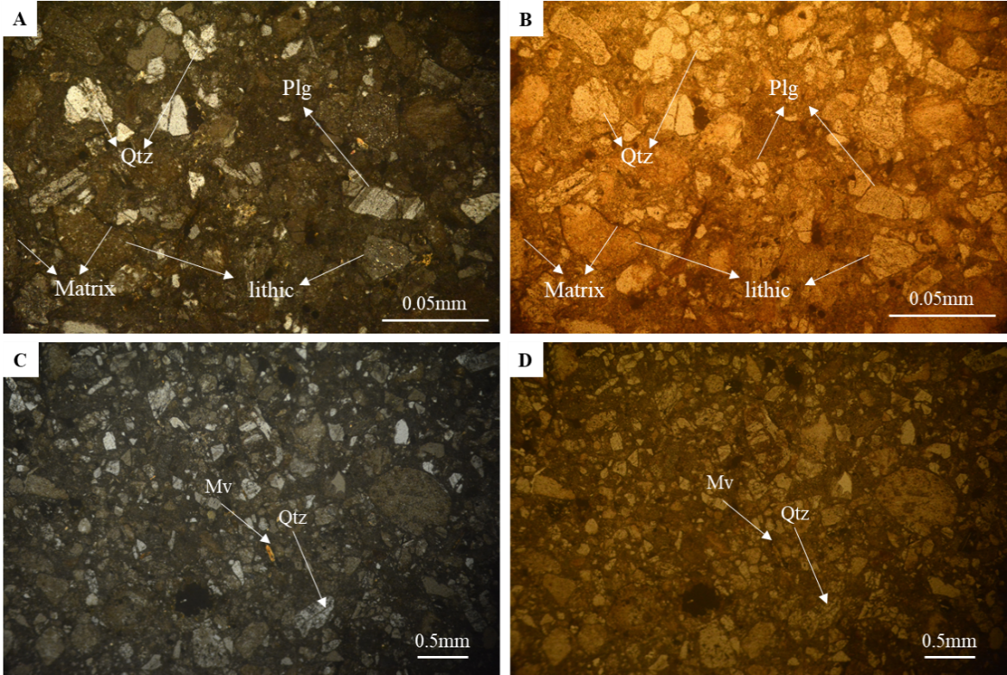
Figure 4.6. A-D) Showing Qtz=quartz, Plg=plagioclase, lithic or rock fragment, Mv=muscovite and matrix, which A&C showing in XPL, B&D showing in PPL.
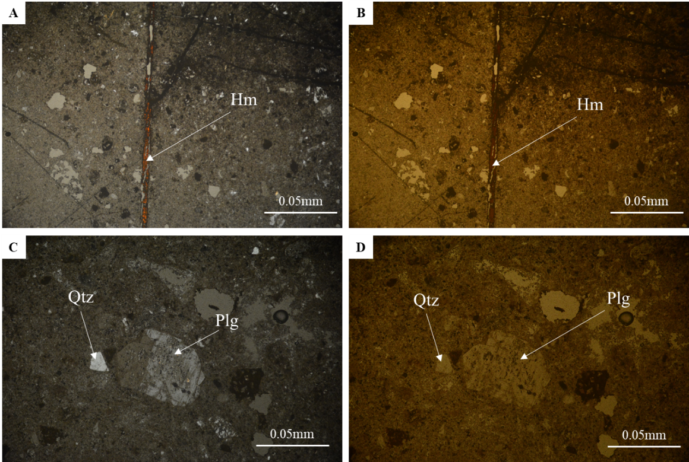
Figure 4.7. A-D) Showing Qtz=quartz, Plg=plagioclase, Hm=Hematite, which A&C showing in XPL, B&D showing in PPL.
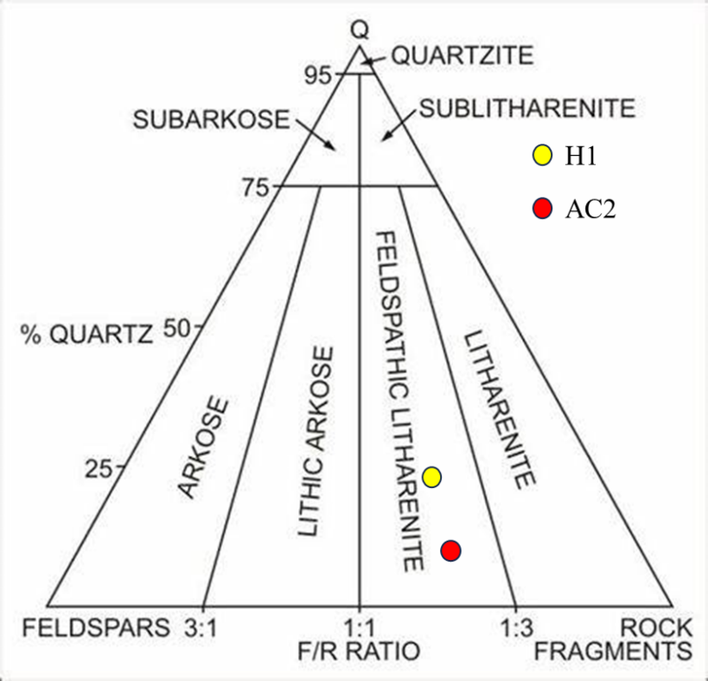
Figure 4.8. Sandstone classification by Folk R.L, 1974.

X-ray fluorescence (XRF)
The results of chemical properties of sandstone from LomPhat area were analyzed by X-ray fluorescence and are summarized (Table 4.1). The major elements that are contained in this sandstone are SiO₂ with the highest percentage followed by, TiO₂, Al₂O₃, Fe₂O₃, MgO, K₂O, P₂O₅, etc. which are present as oxides elements that can be used to identify the sandstone type and depositional environment.
The results indicate that the major oxide contents of the H1 unit are as follows: SiO₂ ranges from 72.33 to 78.66 wt.%, Al₂O₃ from 14.33 to 7.26 wt.%, Fe₂O₃ from 3.47 to 7.99 wt.%, K₂O from 0.75 to 0.21 wt.%, 0.7086 to 0.2928 wt.% TiO₂ and MgO from 1.31 to 0.69 wt.%. 0.41 to 0.4704 wt.% TiO₂
Table 4.1. The major oxide element of sandstone at LomPhat area.
Sample ID: | SiO2  (wt%) | TiO₂ | Al₂O₃ | Fe₂O₃ | MgO | CaO | Na₂O | K₂O | P₂O₅ | LOI | Total
H1 | 72.33 | 0.7086 | 14.33 | 3.47 | 1.31 | 0.15 | 4.02 | 0.75 | 0.10 | 2.52 | 99.69
AC2 | 78.66 | 0.2928 | 7.26 | 7.99 | 0.69 | 0.068 | 1.51 | 0.21 | 0.16 | 2.51 | 99.35

Chemical composition of the examined sandstones
According to chemical compositions from XRF were plotted into several diagrams. The binary plot of Al₂O₃ against TiO₂ is usually used to discriminate sandstones from mudstones. According to XRF results, sample H1 obtain Al₂O₃ (14.3287wt%) and TiO₂ (0.7086wt%), for sample AC2 contain Al₂O₃ (7.2621wt%) and TiO₂ (0.2928wt%). Plotting the examined samples on these plot shows that all samples are sandstone (Figure 4.9).
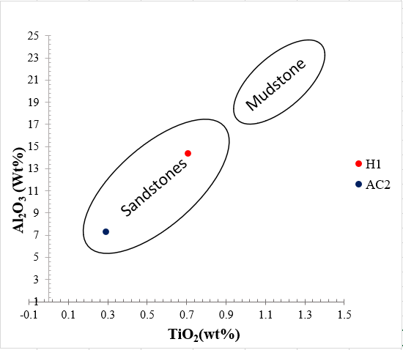
Figure 4.9. Chemical composition of the examined sandstones (Moore 1992).

Environment of deposition sandstone
The binary diagram of Fe₂O₃ versus MgO which characterizes and differentiates marine from non-marine and deltaic sandstones. By XRF results, sample H1 consists Fe₂O₃ (3.4703wt%) and MgO (1.3142wt%), Hence sample AC2 obtained Fe₂O₃ (7.9918wt%) and MgO (0.6935wt%). Plotting the examined samples on this diagram, it shows clearly that all examined samples are non-marine and deltaic sandstone show in (Figure 4.10).
Furthermore, the ternary diagram of MgO - Fe2O3 -(SiO2/Al2O3) categorizes and discriminates the marine from non-marine and deltaic sandstones. By XRF results, sample H1 contain MgO (1.3142wt%), Fe₂O₃ (3.4703wt%), SiO₂/Al₂O₃ (5.0481wt%) and for sample AC2 obtained MgO (0.6935wt%), Fe₂O₃ (7.9918wt%), SiO₂/Al₂O₃ (10.8320wt%). Plot confirms that all the examined samples fall in the field of non-marine and deltaic sandstones shown in Figure 4.11.
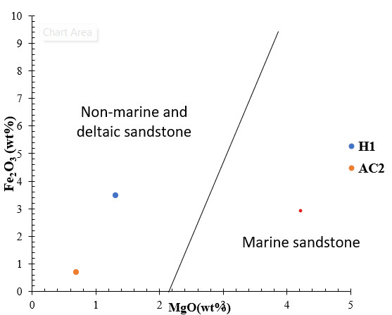
Figure 4.10. Depositional Environments of the examine sandstones Ratcliffe et al. (2007) and Madukwe et al. (2015).
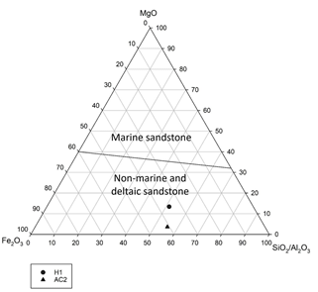
Figure 4.11. Depositional Environments of the examine sandstones Ratcliffe et al. (2007) and Madukwe and Bassey (2015)

Depositional Environment Examine
The relation between log K₂O/Al₂O₃ versus log MgO/Al₂O₃ was used to discriminate marine from non-marine sandstones. According to XRF results, sample H1 composed K₂O (0.7554wt%), Al₂O₃ (14.3287wt%) and MgO (1.3142wt%), Sample AC2 contain K₂O (0.2197wt%), Al₂O₃ (0.6935wt%) and MgO (1.3142wt%) Applying this relation shows that most of the examined samples fall in non- marine field shown in Figure 4.12.
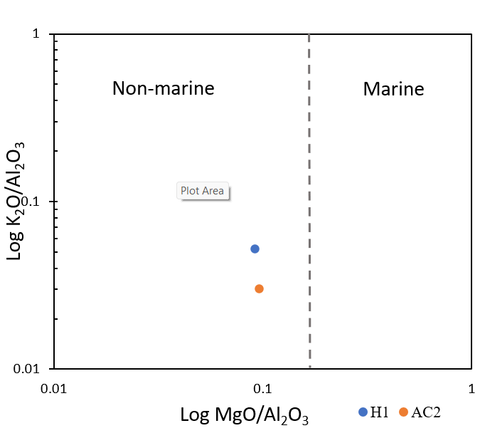
Figure 4.12. Depositional Environment (Roaldest 1978; El-Desoky et al. 2015)

Discussion

Petrified wood
According to hand specimen observation, petrography analysis, and the whole-rock composition in terms of quartz silicification in ray, wood cell, fiber and resin ducts.
Based on petrography analysis under microscope sample J3-P transverse section, consist of wood cell, ray run horizontally from the cambium towards the center of the trunk, resin ducts which microcrystalline quartz silicified. Sample J3-C tangential section, consist of wood cell, elongate ray and fiber. Sample J3-K radial section, consist of wood cell, tracheid ray which is elongate and wood cell were in it, ray-tracheid are in the cross-field in communication by means of very small bordered pits. By all these sections classify it as Plantae kingdom, Gymnospermae clade, Pinophyta division, Pinospida class, Araucariales order, Araucariaceae family, Araucaria genus, Agathis genera (Siegloch & Marchiori, 2016).

Depositional Environment
The depositional environment of sandstone at H1 block and AC2 block in Lom Phat area were characterized based on the thin section analyzed and pointing counting data. The interpretation of depositional environment of sandstone was described by Pettijohn, 1973.
The sandstone at H1 block and AC2 block in Lom Phat area is vary from light gray to uniform medium or dark gray. This sandstone is often poorly sorted, though the degree of sorting can range from well to very poorly sorted, composed of lithic grain and feldspar more than 5 percentages which classify it as Feldspathic litharenite (Folk, R.L, 1974), feldspathic litharenite is the small part in Lithic arenite (Pettijohn, 1973). Lithic arenite found in a wide variety of depositional environments, including fluvial, deltaic, and alluvial sediments associated with active margins (Zaid, 2006). Comparing to the chemical of the binary plot of Al₂O₃ against TiO₂ is usually used to discriminate thatH1 and AC2 are sandstones (Richard M. Moore, 1992). Besides, the plotting of geochemical of Log K₂O/Al₂O₃ versus log MgO/Al₂O₃ plot indicates mostly to non-marine depositional environment (Roaldest 1978; El-Desoky et al. 2015), while both Fe₂O₃ versus MgO binary and MgO–Fe₂O₃ SiO₂/Al₂O₃ ternary plots demonstrate the non-marine and deltaic sandstones. The binary diagram of Fe₂O₃ versus MgO which was developed and modified (Ratcliffe et al., 2007) and (Madukwe, H.Y.; Bassey, 2015) characterizes and differentiates marine from non-marine and deltaic sandstones. Plotting the examined samples on this diagram (Figure 4.12), it shows clearly that all examined samples are non-marine (fluvial/alluvial-lacustrine) environment and deltaic sandstone.

CONCLUSIONS
According to the result obtained from petrography analysis thin section and X-ray Fluorescence, of this petrified wood of Lom Phat district can be summary into:
- samples J3-C, J3-P and J3-K consists of wood cell, fiber, resin ducts, elongate ray and tracheid ray were composed of silicification fill it in, by all of these results identified it as Agathis genera. Agathis genera involved it in Araucaria genus, Araucariaceae family, Araucariales order, Pinospida class, coniterophyta division, Gymnospermae clade, Plantae kingdom. Furthermore, sample H1 under microscope analyzed, which composed of quartz, plagioclase, rock fragment (lithic), muscovite and matrix, where identified it as sandstone. In H1 sandstone sample composed of quartz, feldspar, lithic and matrix, Classify it as Feldspathic litharenite sandstone.
- Samples H1 and AC2 was into classification sandstone. Where it deposited non-marine environment identified it as non-marine (fluvial/alluvial-lacustrine) environment and deltaic sandstone.

REFERENCES
_20191217_070616_440. (n.d.).
Ballhaus, C., Gee, C. T., Bockrath, C., Greef, K., Mansfeldt, T., & Rhede, D. (2012). The silicification of trees in volcanic ash - An experimental study. Geochimica et Cosmochimica Acta, 84, 62–74. https://doi.org/10.1016/j.gca.2012.01.018
Boggs, Jr., S. (2009). Petrology of Sedimentary Rocks. Petrology of Sedimentary Rocks, 7. https://doi.org/10.1017/cbo9780511626487
Carvalho, A., Paiva, J., Louzada, J., & Lima-Brito, J. (2013). The Transcriptomics of Secondary Growth and Wood Formation in Conifers. Molecular Biology International, 2013, 1–12. https://doi.org/10.1155/2013/974324
Hill, R. S., & Brodribb, T. J. (1999). Southern conifers in time and space. In Australian Journal of Botany (Vol. 47, Issue 5, pp. 639–696). CSIRO. https://doi.org/10.1071/bt98093
Madukwe, H.Y.; Bassey, C. E. (2015). Geochemistry of the Ogwashi-Asaba Formation , Anambra Basin , Nigeria : Implications for Provenance , Tectonic Setting , Source Area Weathering , Classification and Maturity. International Journal of Science and Technology, 4(7), 312–327.
Mustoe, G. E. (2008). Mineralogy and geochemistry of late Eocene silicified wood from Florissant Fossil Beds National Monument, Colorado. Special Paper of the Geological Society of America, 435, 127–140. https://doi.org/10.1130/2008.2435(09)
Mustoe, G. E. (2017). Wood petrifaction: A new view of permineralization and replacement. Geosciences (Switzerland), 7(4). https://doi.org/10.3390/geosciences7040119
Nockolds et al., 1978. (n.d.). cox1980.pdf.
Ratcliffe, K. T., Morton, A. C., Ritcey, D. H., & Evenchick, C. A. (2007). Whole-rock geochemistry and heavy mineral analysis as petroleum exploration tools in the Bowser and Sustut basins, British Columbia, Canada. Bulletin of Canadian Petroleum Geology, 55(4), 320–336. https://doi.org/10.2113/gscpgbull.55.4.320
Richard M. Moore. (1992). The Skiddaw Group of Cumbria : early Ordovician Turbidite sedimentation and provenance on an evolving microcontinental margin. 16(1), 1–23.
Saminpanya, S., & Sutherland, F. L. (2013). Silica phase-transformations during diagenesis within petrified woods found in fluvial deposits from Thailand-Myanmar. Sedimentary Geology, 290, 15–26. https://doi.org/10.1016/j.sedgeo.2013.02.014
Schopf, J. M. (1975). MODES OF FOSSIL PRESERVATION 1. In Review of Palaeobotany and Palynology (Vol. 20).
Scurf1eld, G., & Segnit, E. R. (1984). PETRIFACTION OF WOOD BY SILICA MINERALS. In Sedimentary Geology (Vol. 39).
Setoguchi, H., Osawa, T. A., Pintaud, J.-C., Jaffré, T., & Veillon, J.-M. (1998). Phylogenetic Relationships within Araucariaceae Based on rbcL Gene Sequences. In Source: American Journal of Botany (Vol. 85, Issue 11). http://www.jstor.orghttp://www.jstor.org/stable/2446478
Siegloch, A. M., & Marchiori, J. N. C. (2016). Anatomia da madeira de treze espécies de coníferas. December 2015. https://doi.org/10.12953/2177-6830/rcm.v6n3p149-165
Sigleo, A. C. (1979). GEOCHEMISTRY OF SILICIFIED WOOD AND ASSOCIATED SEDIMENTS, PETRIFIED FOREST NATIONAL PARK, ARIZONA. In Chemical Geology (Vol. 26).
Stein, C. L. (1982). SILICA RECRYSTALLIZATION IN PETRIFIED WOOD 1.
TAYLOR, T. (2009). Conifers. In Biology and Evolution of Fossil Plants (pp. 805–871). Elsevier. https://doi.org/10.1016/b978-0-12-373972-8.00021-8
Tucker, M. E. (n.d.). Sedimentary Rocks in the Field THIRD EDITION.
Witke, K., Götze, J., Rößler, R., Dietrich, D., & Marx, G. ünter. (2004). Raman and cathodoluminescence spectroscopic investigations on Permian fossil wood from Chemnitz - A contribution to the study of the permineralisation process. Spectrochimica Acta - Part A: Molecular and Biomolecular Spectroscopy, 60(12), 2903–2912. https://doi.org/10.1016/j.saa.2003.12.045

APPENDIX
